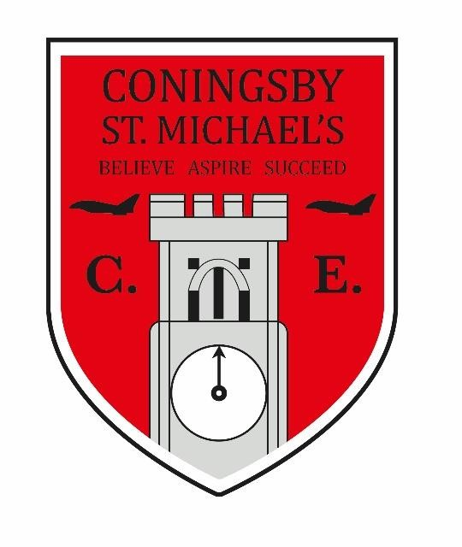

CONINGSBY ST MICHAEL’S PRIMARY SCHOOL

BELIEVE. ASPIRE. SUCCEED.

Coningsby St Michael’s Church of England Primary School

Admission Arrangements
for 20
2
7
/2
8

intake

Written by

S Liley

Feb
ruary

2025

Reviewed and c
hecked by

Executive Headteacher and
Governing Body

September 2026

Next
Review Date

September 202
8

As Jesus welcomes and values children, we at St Michael’s aspire to welcome and value all members of our community. We believe that this welcome and value
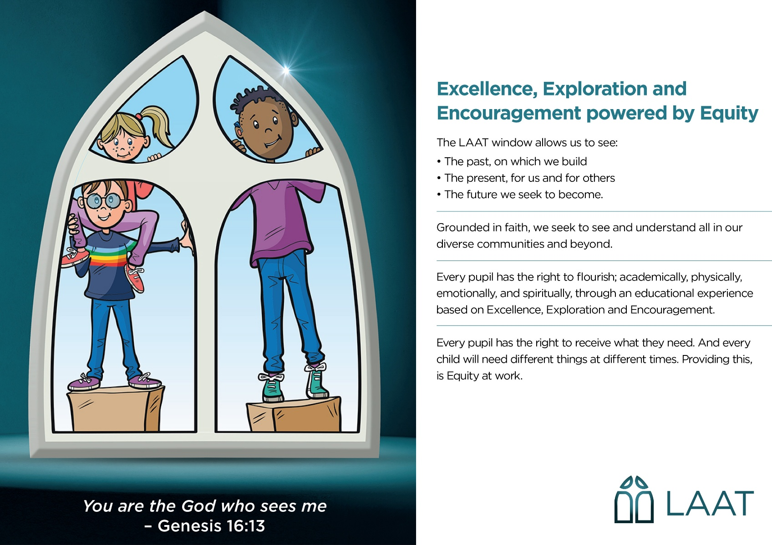
provides opportunities for all to succeed. Matthew 18: 2-5

The Lincoln Anglican Academy Trust (hereafter, LAAT or Trust) is the admission authority for this school. They are responsible for setting the admission number and determining the oversubscription criteria that apply when applications exceed places. Our policy was last determined in March 2023

The published admission number for the school is 45.

Arrangements for applications for places in Reception at Coningsby St Michael’s
Church of England Primary School will be made in accordance with Lincolnshire
County Council's co-ordinated admission arrangements; parents resident in Lincolnshire can apply online at www.lincolnshire.gov.uk/schooladmissions, they can also apply by telephone, or ask for a hard copy application form, by telephoning 01522 782030. Parents resident in other areas must apply through their home local authority. Coningsby St Michael’s Church of England Primary School will use the Lincolnshire County Council's timetable published online for these applications and the relevant Local Authority will make the offers of places on their behalf as required by the School Admissions Code.

In accordance with legislation the allocation of places for children with the following will take place first; Education, Health and Care Plan (Children and Families Act 2014). Remaining places will be allocated in accordance with this policy.

We will allocate places to parents who make an application before we consider any parent who has not made one.
Attending a nursery or a pre-school does not give any priority within the oversubscription criteria for a place in a school. Parents must make a separate application for the transfer from nursery to a primary or infant school. Parents must also make a separate application for the transfer from infant to junior or primary school.
The oversubscription criteria are listed in the order we apply them.
Definitions of terms indicated by numbers are given separately below.
- Looked after children and all previously looked after children including those children who appear to have been in state care outside of England and ceased to be in state care as a result of being adopted (1).
- A brother or sister attending the school at the time of application, or who will be attending the school at the expected time of admission. (2). C. Nearest School: measured by straight line distance (3).
D. Increasing order of straight line distance (4).

If the distance criterion is not sufficient to distinguish between two or more applicants for the last remaining place then a lottery will be drawn by an independent person, not employed by the school or working in the Local Authority Children's Service Directorate.
The intended overall effect of the proposed oversubscription criteria is to maximise
the likelihood that local children will gain places at their local school in an oversubscribed year; it is not possible to guarantee this however.
- A 'looked after child' is a child who is (a) in the care of a local authority, or (b) being provided with accommodation by a local authority in the exercise of their social services functions (see the definition in Section 22(1) of the Children Act 1989) at the time of making an application to a school. A child is regarded as having been in state care outside of England if they were in the care of or were accommodated by a
public authority, a religious organisation, or any other provider of care whose sole or main purpose is to benefit society.
Previously looked after children are children who were looked after, but ceased to be so because they were adopted (or became subject to a child arrangements order or special guardianship order). This includes children who were adopted under the Adoption Act 1976 (see section 12 adoption orders) and children who were adopted under the Adoption and Children's Act 2002 (see section 46 adoption orders). Child arrangements orders are defined in s.8 of the Children Act 1989, as amended by s.12 of the Children and Families Act 2014. Child arrangements orders replace residence orders and any residence order in force prior to 22 April 2014 is deemed to be a child arrangements order. Section 14A of the Children Act 1989 defines a ‘special guardianship order’ as an order appointing one or more individuals to be a child’s special guardian (or special guardians).
- Brother or sister attending the school at the time of application, or who will be attending the school at the expected time of admission. In all cases both children must live at the same address. We include in this criterion:
  - a brother or sister who shares the same biological parents
  - a half-brother, half-sister, step-brother or step-sister
  - a legally adopted child, a child legally adopted by a biological or stepparent

Twins and other siblings from a multiple birth
In these cases all the children will be considered together as one application. If one or more can be admitted within the published admission number the school will go above its admission number as necessary to admit all the children, unless this would make the class too large. The government’s school admissions code makes an exception to the infant class limit in this situation.

Brothers and sisters in the same year group
Where there is only one place available in the school the children will be considered together as one application. The school will go above its admission number as necessary to admit all the children except in cases where this would make the class too large or the infant class regulations prevent this from happening. If the infant class size regulations apply we can only legally offer one place because the government’s school admissions code makes no exception to the infant class size limit for siblings in the same year group.

- Whether this is the nearest state funded mainstream school to the child's address admitting children to the relevant year group; this is calculated by Lincolnshire County Council school admissions team using straight line distance from the Post Office Address Point of the home to the Post Office Address Point of the school.

- Straight line distance as calculated electronically to three figures after the decimal point (eg 1.543 miles) by Lincolnshire County Council school admissions team from the Post Office Address Point of the home to the Post Office Address Point of the school.

We use the distance calculated in this way to apply the final oversubscription criterion.

Home Address
By home we mean the address where the child lives for the majority of term time with a parent as defined in section 576 of the Education Act 1996 who has parental responsibility for the child as defined in the Children Act 1989.

Where a child lives normally during the school week with more than one parent at different addresses, the home address for the purposes of school admissions will be the one where the child spends the majority of term time. If a parent can show that their child spends an equal amount of time at both addresses during school term time, they can choose which address to use on the application.

If a parent has more than one home, we will take as the home address the address where the parent and child normally live for the majority of the school term time.

We do not take into an account an intention to move.

Reserve List
For admission into reception the Governing Body will keep a waiting list which we
call a reserve list. If your child is refused a place at this school they are automatically put on the reserve list, unless you have been offered a higher preference school. This list is in the order of the oversubscription criteria, as required by the School Admissions Code. This means that names can move down the list if someone moves into the area and is higher placed on the oversubscription criteria. The admission authority do not take account of the time you have been on the list.

For intake years the list is kept by the School Admissions Team until the end of August each year. After this the School Admissions Code requires that schools keep the reserve list until the end of the autumn term, the list will be kept by the school for the full academic year. You should contact the school for information about the reserve list.

The school keep reserve lists for oversubscribed year groups. Schools will clear the reserve list at the end of each school year, if you wish your child to remain on the list you must let the school know. If your circumstances change you must let the school know so that they can rank the list accurately and allocate places in accordance with the oversubscription criteria to comply with the School Admissions Code. The Governing Body do not take account of the time you have been on the list.

SEN Hub
The SEN Hub is a central part of the school’s provision for some of our pupils with Special Educational Needs and Disabilities and plays an important role in supporting our inclusive admissions arrangements. The Hub provides targeted, flexible support designed to ensure that pupils with a range of additional needs can access the curriculum, regulate effectively, and participate fully in school life. While the presence of the SEN Hub does not form part of the admissions criteria, it enables the school to meet the needs of pupils admitted with identified or emerging SEND by offering personalised interventions, specialist resources, and tailored guidance from trained staff. The SEN Hub ensures that all pupils are supported to settle successfully, make progress, and thrive within a mainstream environment in line with the principles of equity, inclusion, and early intervention. For further information on admissions to the SEN Hub, you can make contact with our Special Educational Needs and Disabilities Co-ordinator in the first instance to discuss the process in more detail. It is important that we note there is specific criteria for pupils to be referred into the SEN Hub and the use of the Hub is at the discretion of the Head Teacher.

Appeals
If a place cannot be offered, then parents can appeal against the decision. The procedures for appeals relating to admissions will be in accordance with all relevant legislation. Please contact the school for information on how to appeal. The decision of the independent appeal panel is binding on all parties.

Midyear Admissions
Coningsby St Michael’s Church of England Primary School will accept admissions up to the Published Admission Number into all year groups. In the event that this would cause an infant class to be unlawfully large cause prejudice to the provision of efficient education or the efficient use of resources it may be necessary to refuse a place although the year group has not reached the school's published admission number. If there are more applications than places then the oversubscription criteria will be used to decide who should be offered the place. If it is necessary to refuse a place then you will be told of the independent appeal system. Parents can apply online at www.lincolnshire.gov.uk/schooladmissions or call 01522 782030 for a paper form.

Fair Access
Local Authorities are required to have Fair Access Protocols in order to make sure that unplaced children who live in the home local authority, especially the most vulnerable, are offered a place at a suitable school as quickly as possible. This includes admitting children above the published admissions number to schools that are already full.

Children of UK Service Personnel (UK Armed Forces)
In order to meet the government’s military covenant aimed at helping UK service personnel, and Crown Servants returning from abroad we have adopted the following arrangements.
For families of UK service personnel with a confirmed posting to the area, or crown servants returning to live in the area from overseas, the Governing Body will:
- Process an application in advance of the family arriving in the area provided the application is accompanied by an official letter that declares a relocation date and a Unit postal address, intended address or quartering area address. This address will be used when considering the application against the school's oversubscription criteria.
- Accept a Unit postal address or quartering area address for admissions purposes for a service child, where the parent requests this.

The Governing Body will not refuse a service child a place because the family does not have an intended address or does not yet live in the area.

Evidence of an intended address will be required such as tenancy agreement, or mortgage statement. Please contact the school for more details.

For late co‐ordinated applications and in-year applications supported by the appropriate military documentation we will aim to remove any disadvantage to UK service personnel (UK Armed Forces).

The school's Governing Body will consider whether:

- An application from that address would normally succeed in an oversubscribed year.
- There is any child on the reserve list with higher priority under the oversubscription criteria. This is because we must only allocate places based on the criteria and must not admit a Services child ahead of another child with higher priority under the criteria.
- The prejudice from admitting an extra child would be excessive.

The Governing Body have discretion to admit above the admission number in these circumstances if they wish, but are not obliged to do so. If a place is refused, you will be informed of your right of appeal.

We will need the notice of posting or official government letter and confirmed address before we can consider an application under these arrangements.

Fraudulent or Misleading Applications
As an admission authority we have the right to investigate any concerns we may have about your application and to withdraw the offer of a place if we consider there is evidence that you have made a fraudulent claim or provided misleading information, for example a false address was given which denied a place to a child with a stronger claim.

We reserve the right to check any address and other information provided so we can apply the oversubscription criteria accurately and fairly.

Admission of Children below Compulsory School Age
Coningsby St Michael’s Church of England Primary School provides for the admission of all children in the September following their fourth birthday.
Where we have offered a child a place at our school:
- that child is entitled to a full-time place in the September following their fourth birthday;
- the child’s parents can defer the date their child is admitted to the school until later in the school year but not beyond the point at which they reach compulsory school age and not beyond the beginning of the final term of the school year for which it was made, whichever is the sooner;
- where the parents wish, children may attend part-time until later in the school year but not beyond the point at which they reach compulsory school age.
Parents interested in deferring admission or arranging part-time attendance must contact the school to discuss this.

Admission of Children outside their Normal Age Group
Parents may seek a place for their child outside their normal age group, for example if the child is gifted and talented, or has experienced problems such as ill health. Parents wishing to make these requests must contact their home local authority for guidance on the procedure to follow. Parents resident in Lincolnshire should call 01522 782030 or email schooladmissions@lincolnshire.gov.uk for advice on the procedure to follow.

It is important for parents to note that they will have the opportunity and responsibility to provide whatever evidence they wish to support their request.

Decisions will be made on the basis of the circumstances of each case and in the best interests of the child concerned.

This will include taking account of:
- the parent’s views;
- any available information about the child’s academic, social and emotional development;
- where relevant, the child's medical history and the views of a medical professional;
- whether the child has previously been educated out of their normal age group;
- any evidence that the child may naturally have fallen into a lower age group if it were not for being born prematurely
- the views of Coningsby St Michael’s Executive Headteacher

