Science
In science this week we will be looking at the parts of the eye and how it works.
Which of these statements are true or false?
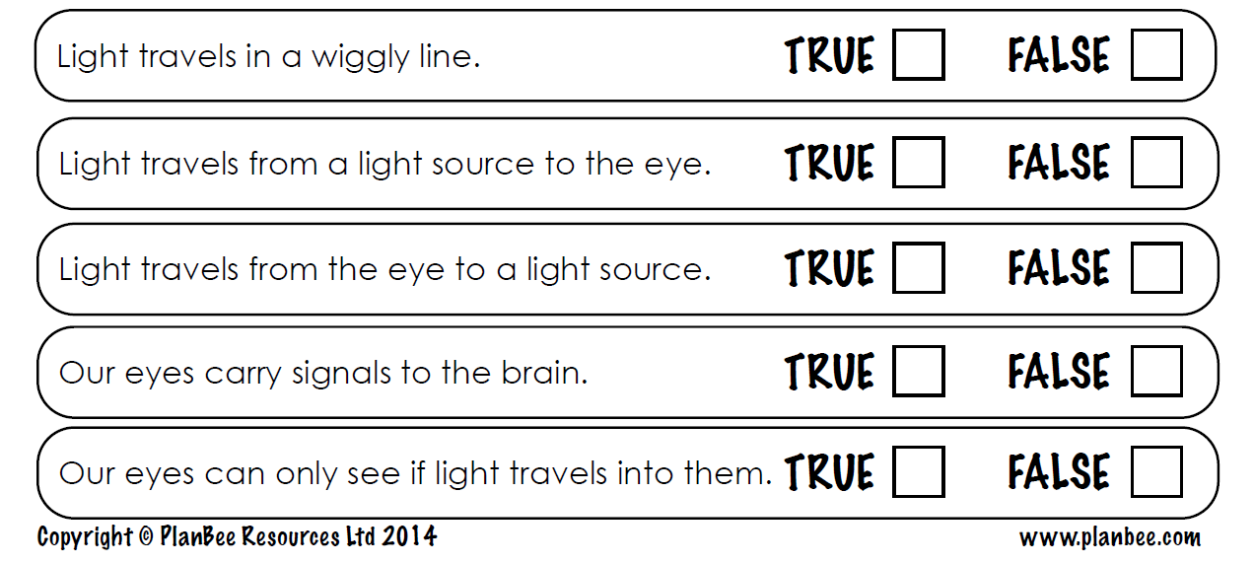

Research the parts of the eye and label the diagram below and fill in the information:


