SPAG:
We are looking at the use of there, their and they’re.
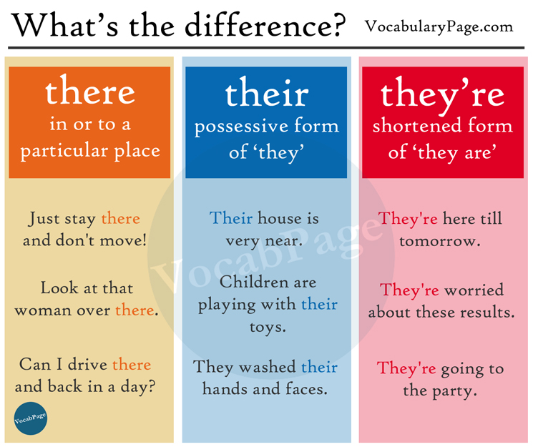

Can you use the above information to help you place in the correct there each time? Currently I have just used ther for each one.

The camels stared at ther next meal whilst the riders picked up ther reward. Ther were three of them and they had travelled far to reach ther destination. “Ther weary,” thought the chief as he gave them ther money and asked them to put ther bags down. “Over there will do,” he said, catching ther glances. Ther a funny bunch, he thought. Ther camels chewed in silence.

We are also looking at expanded noun phrases.
https://www.youtube.com/watch?v=4fCk8ye4jio
Use the video to help you understand what they are and then try using some to describe each picture below.




English:
In English we have been creating information texts about a deadly creature. Could you choose a different one from last week and use the boxed up grid to help you plan and write one. Remember an information texts purpose is to inform the reader and help them learn something new.

Fill out the grid below to generate your ideas.
What it is – definition

What it looks like – description

Where it is found – habitat/location

What is it best known for – key aspect or concern

Final issue, important or amazing fact/point.

Choose a creature to write about. What makes it deadly? What does it look like? Where does it live?



