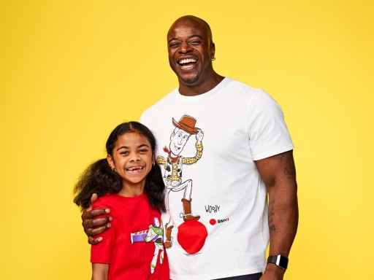
Big Write
Thursday 18th March 2021
Can you make us laugh?

Can you write a funny story or poem for Red Nose Day?

