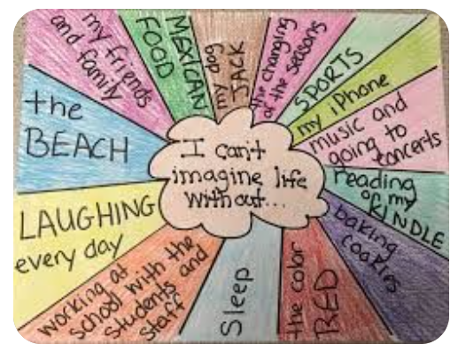
Thursday 18th March
PSHE
What can’t you imagine life without?
Draw a design like the example, listing all the things that are important to you.

