Science 15.03.21
Task 1
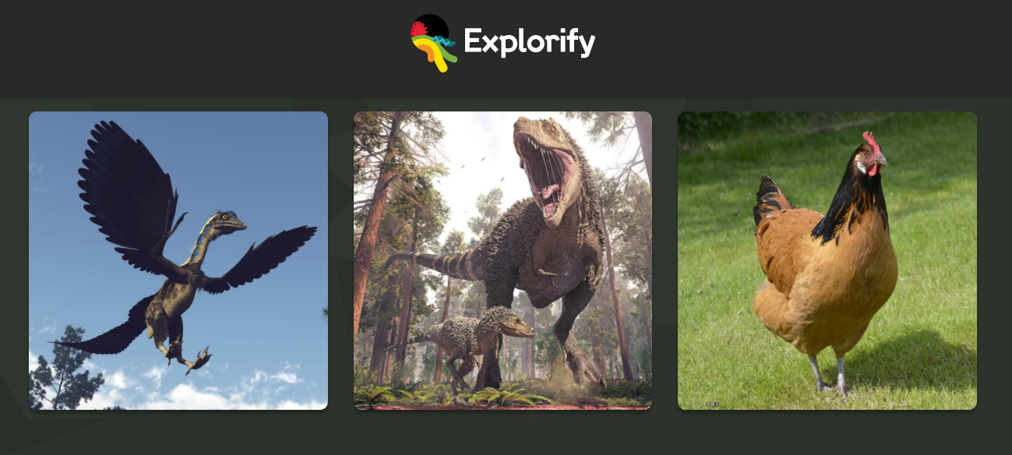
Look at the images above, write down a list of similarities and differences between the images.
Now choose an odd one out and explain your reasoning.

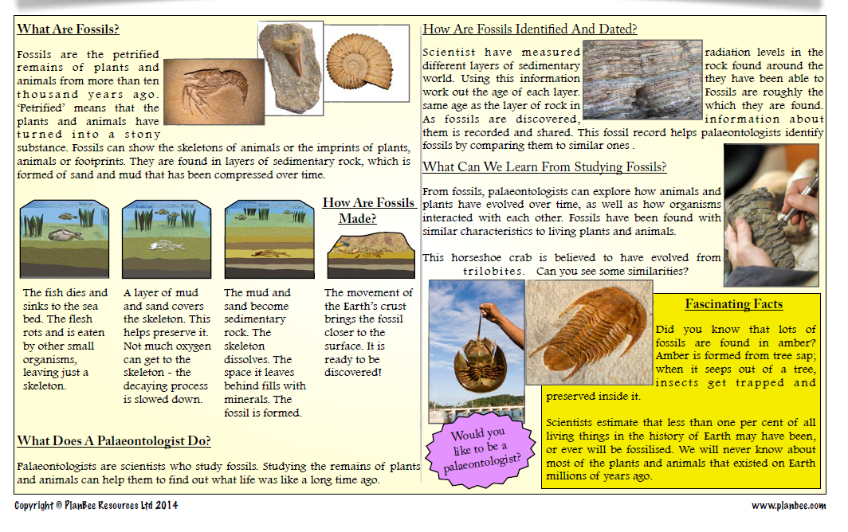
Task 2

Look at the fossil record above and answer the questions below using a format similar to the one shown.
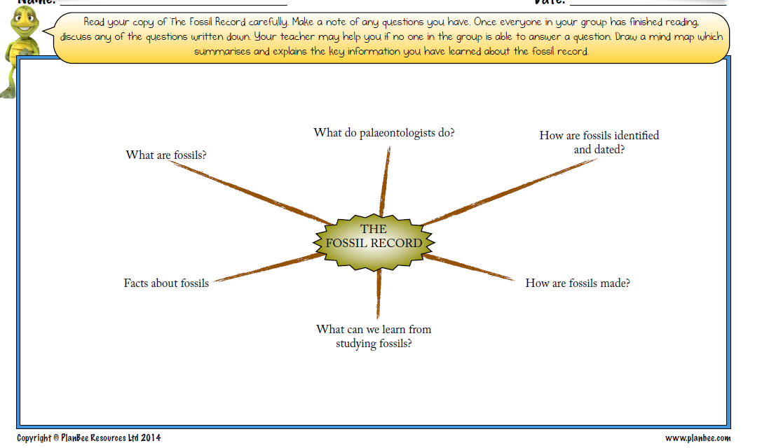

Task 3
Create a fact file on Charles Darwin. Below are some things to consider:


