5.3.21 LQ: Can I order three numbers up to 50?

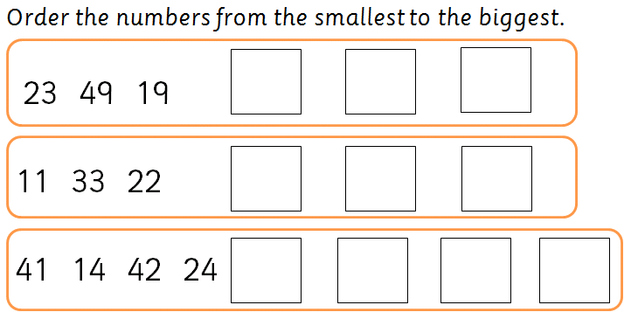
˂ less than
˃ more than
= equal

Extra challenge


