4.3.21 LQ: Can I compare two numbers using ˃, ˂ and =?

Less than <
more than >
equal to =

Use the number track to compare the two numbers using words
and inequality symbols.

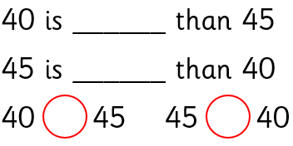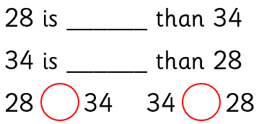

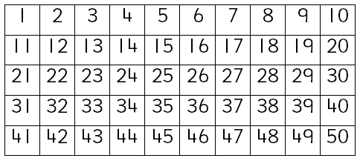
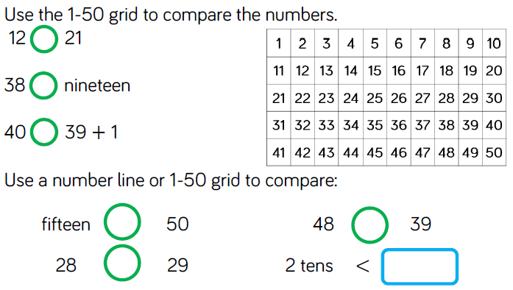

Extension
Find four more solutions for ?

