3.3.21 Challenge Can I compare two pictures of objects using ˃, ˂ and =? | I | CT | TA
˂ less than
˃ more than
= equal
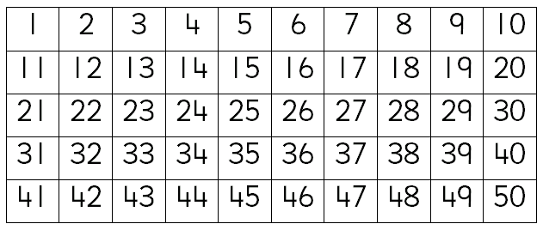
Complete each box using <, > or = .
Say and write the number sentences for each one.


