1.3.21 Challenge Can I use a number grid to find one more and one less?
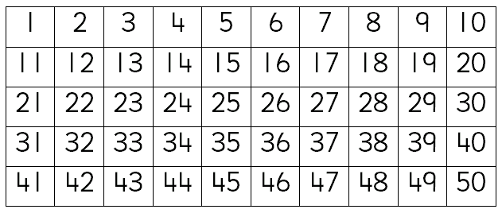
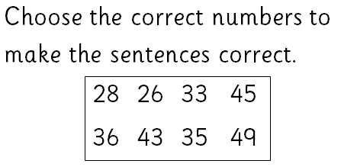

is one less than 27.

34 is one less than .

is one more than 44.

50 is one more than .

