23.2.21 Can I identify and represent numbers up to 50 as tens and ones?
Make these numbers using apparatus, group them into 10s and 1s and then complete the sentences and part whole models.
32
32 There are _____ tens and _____ ones.
_____ tens + _____ ones = ______

47 There are _____ tens and _____ ones.
_____ tens + _____ ones = ______

Extension
What number is represented in the grid?
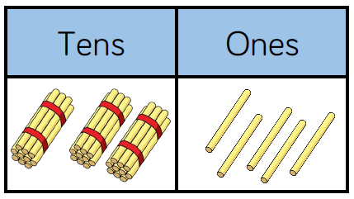
There are _____ tens and _____ ones.
_____ tens + _____ ones = ______



