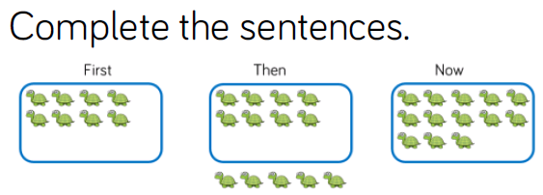
Monday’s Maths 18.1.21

Now there are _____ turtles.
Then _____ more joined the group.
First there were _____ turtles.

___________________________________



Now there are _____ penguins.
First there were _____ penguins.
Then _____ more joined the group.

__________________________________________
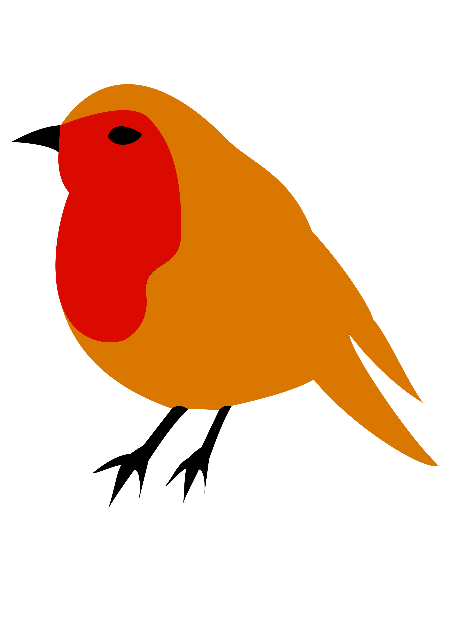



First there were _____ robins.
Then _____ more joined the group.
Now there are _____ robins.

Can you make up your own adding story?

First there were ____

______________.
Then _____ more joined the group.

Now there are _______

________________.

