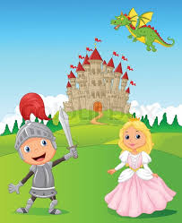

YEAR 1 ‘Kings, queens, knights and dragon’ day.

Dear Parents and Carers,

As part of our Topic work this term, we would like to invite the children to a ‘Kings, queens, knights and dragon’ Day in school on Friday 16th July. The children are invited to dress up in an outfit such as a princess, queen, knight, prince, king or they may want to dress as a dragon for the day!

During the day, the children will take part in lots of different activities such as: jousting, shield making, knight training and medieval dancing. We will be hoping to hold a medieval banquet in the afternoon and will be asking for a voluntary contribution of £1 towards the cost of the day and activities.

If you do have any questions about the day, please do not hesitate to speak to your child’s class teacher.

Yours sincerely,

Mrs Pobjoy, Mrs Pickering and Mrs Chiumento

