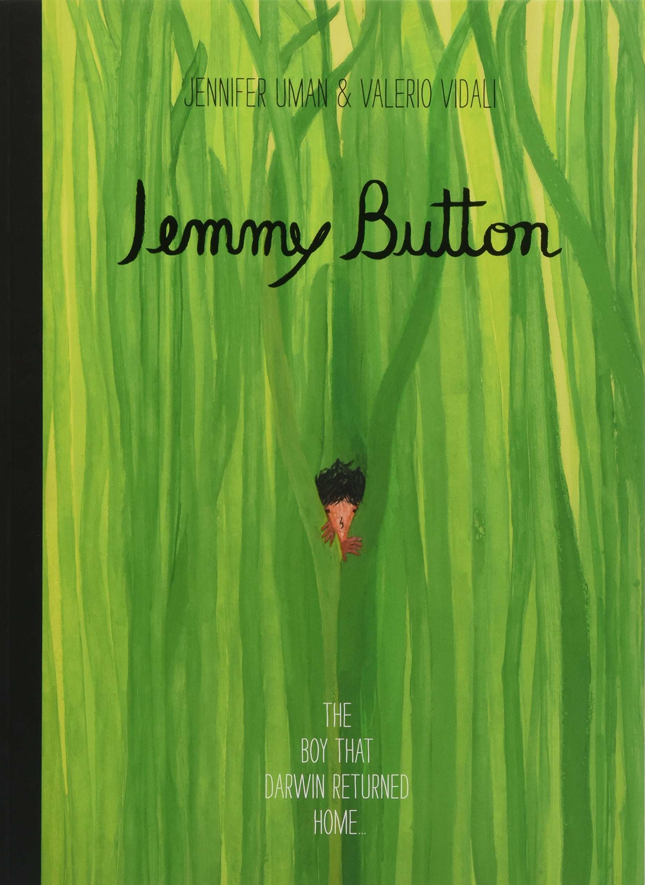
Year 3 Term 4 curriculum – Who would live in a place like this?
As Coningsby Geographers we will be comparing cities and the countryside, including finding capital cities on a map. We will also be locating the Northern and Southern Hemisphere and comparing the climate of the UK and the tropics.
As Coningsby Mathematicians we will continue to develop our understanding of money. We will move on to create our own bar charts and pictograms to represent a variety of data. We will finish the term by investigating units of measurement and calculating the perimeter of a given shape.
As Coningsby Artists we will be looking at Digital Art. We will be studying a range of artists, such as Picasso, Seurat and Mondrian, and using their style to recreate a piece of art.
As Coningsby scientists we will be investigating light and dark. We will learn about how light travels, reflections and how to stay safe in the sun. We will also investigate how shadows are created and find out which materials are best for blocking light.
Dear Parents and Carers,
We hope you had a lovely half term. In Term 4, Year 3 will have indoor on Wednesday and Friday with a focus on dance and gymnastics. Please ensure children have the correct PE kit in school and tape for earrings and hair ties are provided in their bags.
If you have any questions, concerns or needs anything at all, please do not hesitate to contact us.
Mrs Appleyard and Miss Plaskitt.
As Coningsby believers we will continue to learn about the Trinity and the Christian belief that God has three ways of being. We will also learn about the gospel’s teachings of Jesus’ birth.
As Coningsby Authors we will be reading Jemmy Button by Jennifer Uman and Valerio Vidali. We will be writing our own poems about the setting, completing diary entries as Jemmy Button and writing a biography about a famous explorer.

