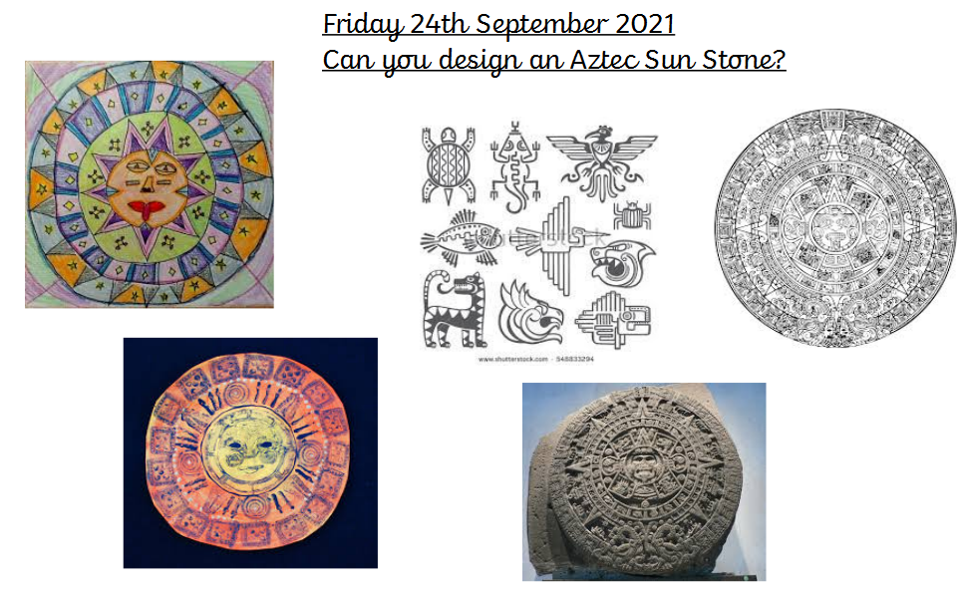

Using whatever materials you have available, can you create an Aztec sunstone? You can find more information here: https://www.dkfindout.com/uk/history/aztecs/aztec-calendar/

