21.9.21

Order the following numbers from smallest to largest and place on a number line.
- -6 10 -5
- -50 25 -75
- 8 -24 0
- -9 27 -12

Challenge
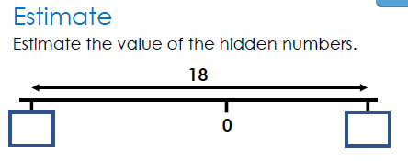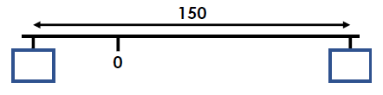

22.9.21
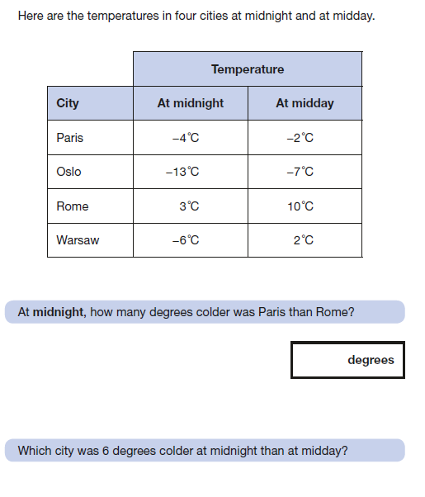
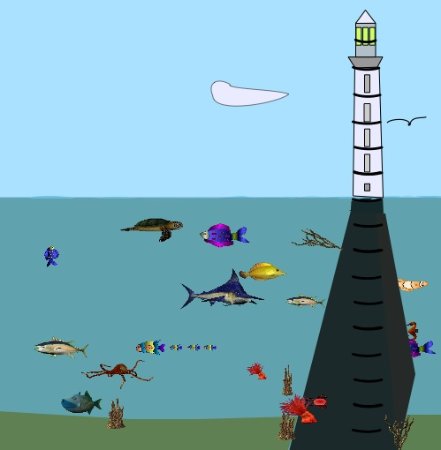
1. What number should be where the light shines from the lighthouse?
2. What number should be where the (head of the) seagull is?
3. What number should be where the (mouth of the) red crab, near the bottom, is?
4. How far is it down from the (head of the) seagull to the (mouth of the) yellow fish?
5. How far is it from the turtle, near the surface of the water, to the crab?
6. There's a little brown sea-horse to the right of the lighthouse support. How far from the surface is it?
7. How high above the sea level is the seagull flying?
8. How far is the seagull from the sea-horse?
9. How high is the pointed end of the cloud?
Challenge
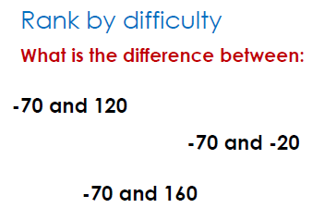

23.9.21
Use digits 1, 2, 3, 4, 5, 6, 8, 9.
You can only use each digit once.
Make 2 4 digit numbers and add together.

1, What is the largest number you can make? Is there more than one solution?
2, What is the smallest number you can make? Is there more than one solution?
3, Write the answer as Roman numerals.
4, Show the calculations using place value counters.

5, Repeat using digits 0,1,2,3,4,5,6,7,8,9

Challenge
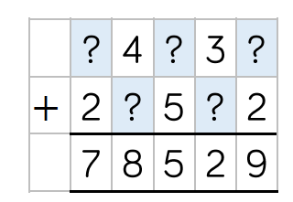

24.9.21
You are going to subtract 2 5 digit numbers. Each digit can only be used once in your subtraction.
- What is the largest number you can make? Is there more than 1 answer?
- What is the smallest number you can make? Is there more than 1 answer?
Convince me.
Can you write a column subtraction where the solution contains each digit from 1-5 once only. The digits can be in any order.
Is there more than 1 solution?

Challenge



