English and SPAG.
In SPAG (spelling, punctuation and grammar) we are looking at different sentence types. Use this video to help remind you of what each one looks like and what it has in it.
https://www.bbc.co.uk/bitesize/guides/zxqnfg8/revision/1
Task 1
Find and write a definition for each sentence type below:
Simple:
Compound:
Complex:
Task 2
Decide whether these sentences are simple, compound or complex. Give reasons for your answers.

The dog barked.

The dog barked and the cat purred.

The dog barked at the fish and chip van.

The dog barked while the cat crept under the car where it waited patiently.

The dog with the red collar barked at the fish and chip van at the side of the road.

Task 3
Underline the subordinate clauses in one colour, the main clauses in another and the subordinating conjunctions in another. Place a colour key to say which one is which.

Excited by the golden crown, the prince sat down.

The car slows down as soon as the breaks are applied.

After boiling the water, stir the soup gently.

The shark, which is found around the world, generally lives in sea water.

English
In English we are looking at persuasive writing.
Task 1
With a family member, take in turns to verbally persuade each other that these are good ideas.

A snowman to come into the kitchen out of the cold.

A dragon to stop eating maidens.



Task 2
Rewrite the text below. Where you see some question marks can you add in a word or two that would help persuade other people to buy the house.
For sale - a ?????? opportunity to buy a ???????,
?????? house. This ?????? building would make the ?????? family home. ?????? placed near shops and restaurants.
The house has a ?????? garden that is ?????? and very ??????. With 5 ?????? bedrooms you will have more than enough space for the whole family.

Task 3
Below is an example of an advert to persuade people to apply for the role of a priest in Aztec times. Use it to help you write you own advert for becoming a warrior in Aztec times. Use the boxed up grid to help you plan your ideas first.

Priest, a job above all others!
Have you ever wanted to be more important than your friends? Have you ever wanted to have free accommodation for life? If the answer to these questions are yes, then this could be the job for you! Priests are loyal and highly thought of by everyone so it’s obvious to all that it’s a job worth fighting for.
Firstly, if you are tired of your mundane 9-5 job, for very little pay or reward, now’s your chance to make a difference to your tribe by becoming a priest. Furthermore, if you enjoy the sight of someone else’s blood splattered wildly all over your clothes then apply now!
In addition, everyone knows that being a priest means that you can smell uncomfortably bad and still be accepted by others (well they have no choice if they don’t want to be the next human sacrifice).
Finally, applying for this once in a lifetime role means your power will be unquestioned by virtually everyone else. Without a doubt, you will earn the respect and adulation of all others. 95% of the Aztec population agreed that this is a job not to be missed. Wonderful, rewarding and extremely powerful.

APPLY NOW, DON’T DARE TO DELAY!
Remember, those that are not highborn (or well educated) need not apply.
Beginning: intro – hook to engage the reader.

Middle: highlight three/four things that make this job role special (persuade)

Key skills required: list 3 key skills required.

Useful information: list any useful info for the applicant. How do they apply? Who too?

Concluding slogan. Slogan to seal the deal.

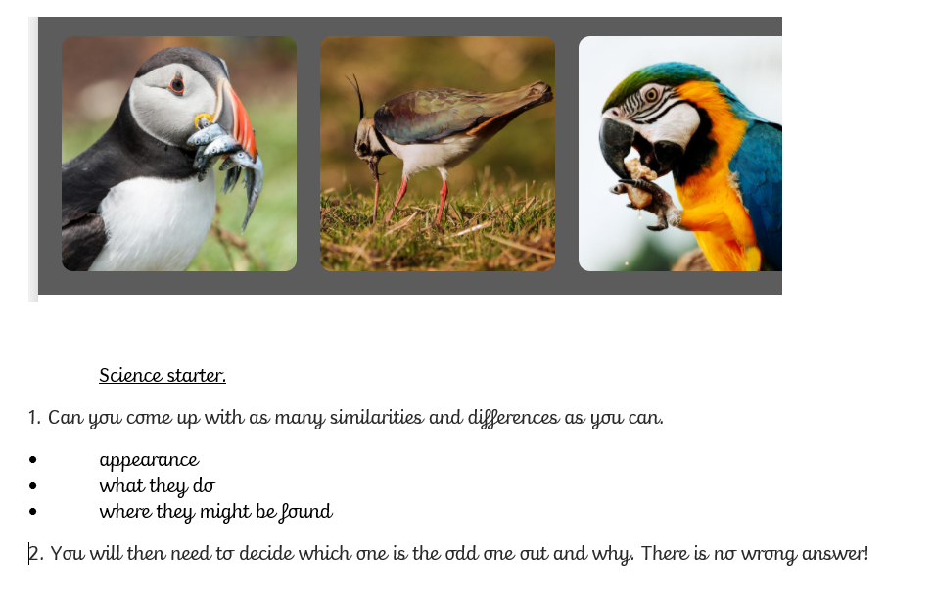
Science Task 1
Tasks 2
You may need to do some of your own research online for this. This video may also help you.
https://www.youtube.com/watch?v=CWFyxn0qDEU
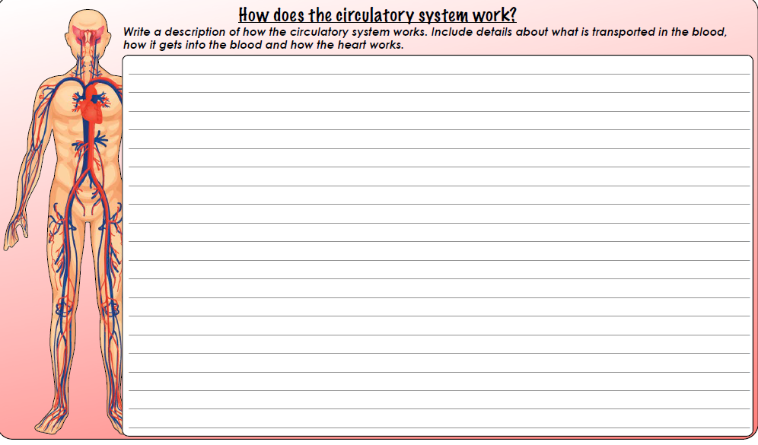

Your description:

