Monday
Please look through the slides for Monday on the Maths wk 5 document.

Then complete this task
You have 5 digits 1,2,3,4,5.
Use these to make a 4 digit multiplied by 1 digit calculation.

- What is the largest product you can make?
- What is the smallest product you can make?
- Can you make an odd/even product?
- Use a model to show your calculation

Challenge
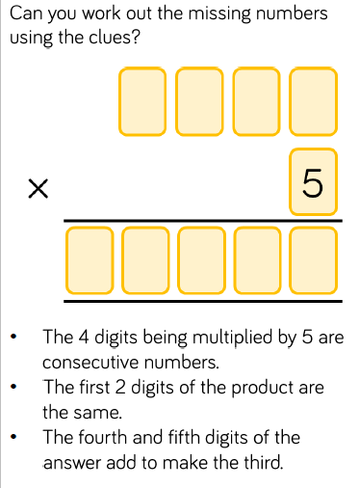

Remember to complete the rapid recall work as well.
Spend at least 5 minutes on Times Table Rock Stars

Tuesday
Please look through the slides for Tuesday on the Maths wk 5 document.

Task
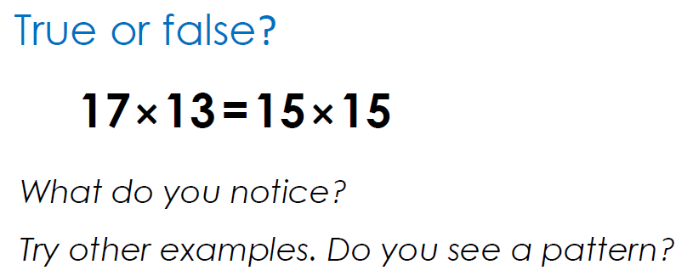

Challenge
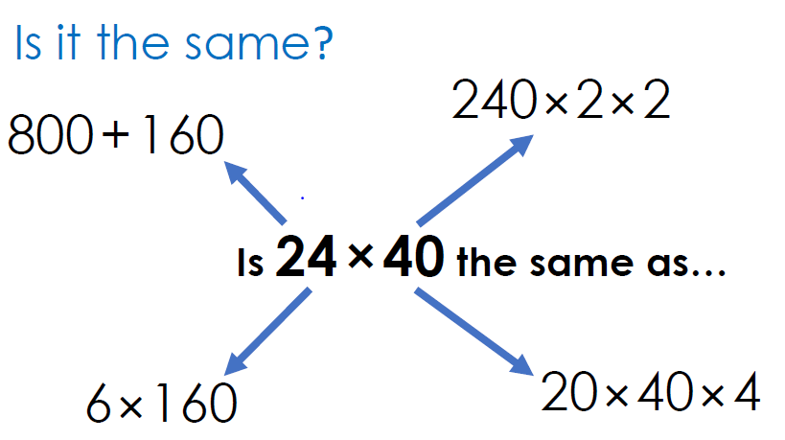

Remember to complete the rapid recall work as well.
Spend at least 5 minutes on Times Table Rock Stars

Wednesday
Please look through the slides for Wednesday on the Maths wk 5 document.

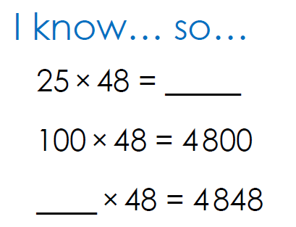

Remember to complete the rapid recall work as well.
Spend at least 5 minutes on Times Table Rock Stars

Thursday
Please look through the slides for Thursday on the Maths wk 5 document and complete the task.
Challenge

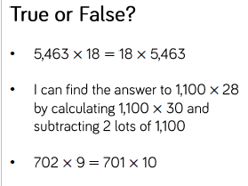
Remember to complete the rapid recall work as well.
Spend at least 5 minutes on Times Table Rock Stars

Friday
Please look through the slides for Friday on the Maths wk 5 document and complete the task.
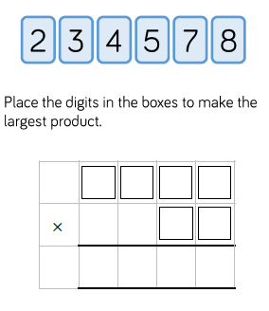
What is the largest product? Convince me
What is the smallest product? Convince me
What is the largest product you can make using consecutive numbers?
You can change 1 of the digits for a 0,1 or 9 which digit would you change to make a larger number? Why?
You can change 1 of the digits for a 0,1 or 9 which digit would you change to make a larger number? Why?
Write a word problem to go with 2 of your calculations

Challenge
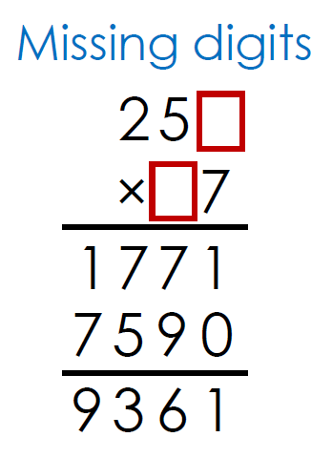

Remember to complete the rapid recall work as well.
Spend at least 5 minutes on Times Table Rock Stars

