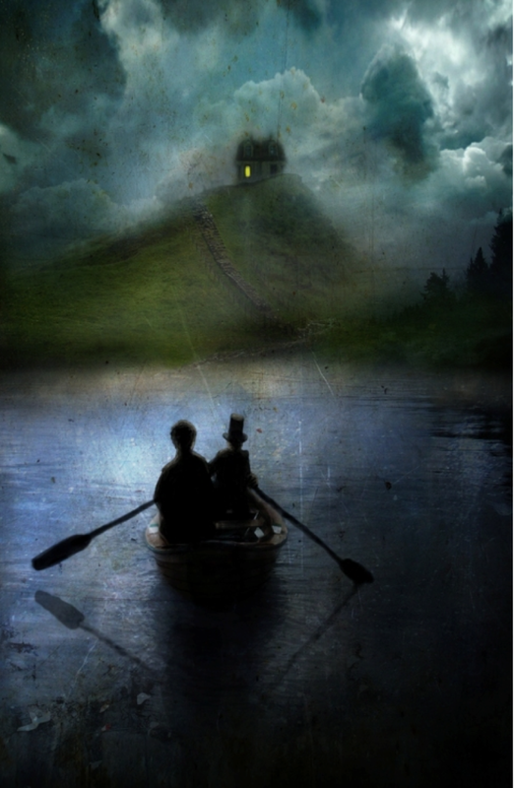
Big Write
Friday 8th October 2021
LQ: Where are they going?
Can you use your imagination to describe who is on the boat? Where are they going? Why?
Describe the sensation of rowing across the lake in the dead of night. Try to use all your senses to paint a picture for the reader od this scene. You might want to create a rough plan first using an OSIE grid (like the one below) or just jot some ideas on rough paper before you get started.

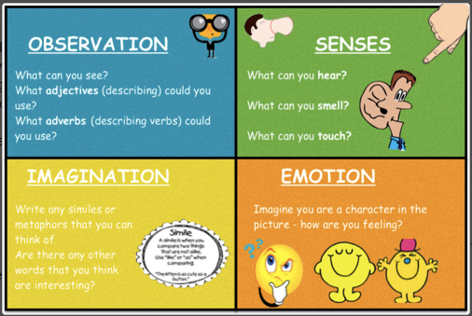
Example of an OSIE planning grid:

