Home learning (4.10.21)

Guided reading.
In guided reading we are looking at poetry. Use the link below to watch some people perform poetry.
https://www.youtube.com/watch?v=ByAg5aoyAN4
Read and try to remember the poem below so that you can perform it to a family member,

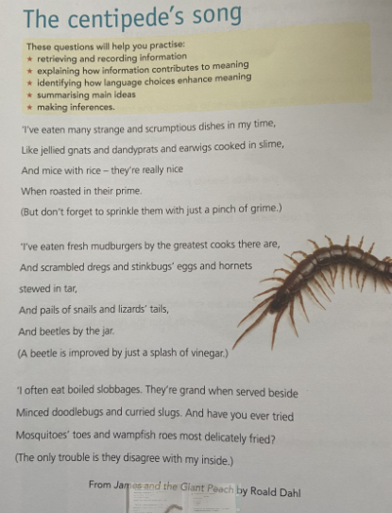
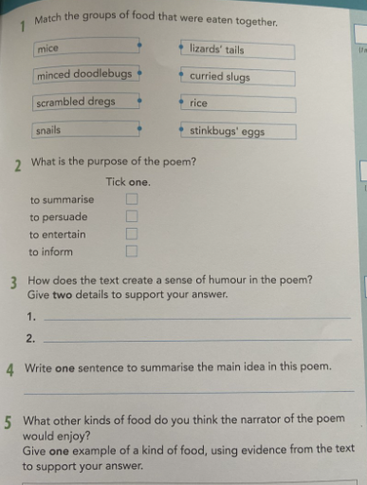
Use the poem to answer the questions above.
1.

2,

3.

4.

5.

English
In English we have been looking at persuasive writing. Last week we created a persuasive advert to become a warrior. This week will be applying for the role of a warrior in Aztec times.
Below is an example of a persuasive letter applying for the role of priest in Aztec times.

Mr D. Saunders,
30 Palace Avenue,
London,
LN3 4AZ.
Wednesday 2nd October 1352.

Mr Hepakachu,
32 Aztec road,
Mexico,
North America.

Dear Mr Hepakachu,

I am writing to you to apply for the role of High Priest of the Aztec kingdom. Firstly let me explain my background. I am son to a priest myself so I have highborn blood. Although I do not have a lot of experience within the role, I am an extremely quick learner who can adapt swiftly to different situations.
In addition, I would like to discuss my physical attributes. As a child (sixteen) people have often undermasted my strength and physical presence, however I can assure you I am extremely capable of fulfilling all the jobs required within this role.
Furthermore, if I was to be given this privileged responsibility I would make sure that I will take my human sacrifices very seriously. I have no issues with blood and understand the importance of sacrificing others to keep our Gods content. My robe, which I know will be blood-splattered, will be worn with pride at all times.
In conclusion, I hope I have convinced you that I would be a marvellous asset to the priest team. I would relish the opportunity to discuss this further. I eagerly await your response,

Yours sincerely,
Mr Saunders.
Use a gird like the one below to first plan out your ideas to help create your own letter to apply for the role of warrior. Then write your formal letter.
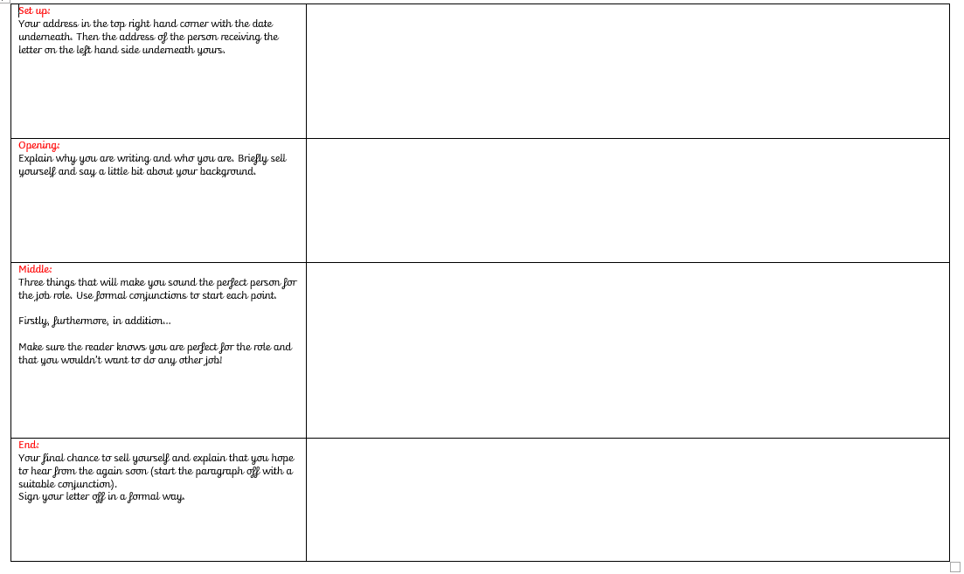

SPAG
In SPAG we are looking at adverbs. Watch the video below to help you understand what adverbs are and their function in a sentence.
https://www.youtube.com/watch?v=pRTCQTHZsVc
Task 1
Can you find the adverbs in the paragraph below?
Smugly, I had pictured myself expertly growing the best cress seeds in the class-mine tall, green and healthy-looking while all the others were wilted, thin and mangy. Sadly, this turned out not exactly to be the case. Apparently, we were supposed to set up four different dishes and treat the things differently to show some point or other. I wasn’t really listening and just set up one dish.

Task 2
Adverbs can change the mood of a sentence or paragraph written.


The man watched fearfully as the child balanced precariously on the edge of the pool.
Can you see the adverbs and how they change the mood in each one?
The man watched proudly as the child balanced skilfully on the edge of the pool.

Now can you Change the adverbs to change the mood!
- The child paddled happily watching the water flow lazily over the edge.
- Kelsie ran slowly along the beach as the waves rolled gently in.
- The boy listened hopefully as the footsteps came reassuringly closer.
- The women waited expectantly for the number 59 bus to arrive punctually.

Science
Watch the video on the digestive system.
https://www.youtube.com/watch?v=eSEYPO30AN0
Can you draw your own diagram similar to this and write down the key parts of the digestive system on it. Can you also give a definition of what each one does?



