SPAG
Task 1
Sometimes it is important to add in extra information to a sentence to help the reader.
Look at how the where, when, how and why have been added into the blue sentence.
Can you add in the where, when, how and why like this example?
The boy woke up late, jumped out of bed and dashed out.
Can we add the when, how, where and why?
The boy woke up late that morning (when) jumped out of bed and dashed madly (how) out to school (where) to avoid yet another detention (why).

Your turn now to have a go. Can you add them into the sentences below? Can you make up one of your own?
- The dragon heard a noise, stood up and guarded the entrance to the cave.
- The alien landed, checked the outside temperature and took off.

Task 2
This week we are looking at apostrophes for contracted words. Watch this video first.
https://www.youtube.com/watch?v=gubPH3WEurg
Can you now write down the original word(s) for these contracted words?
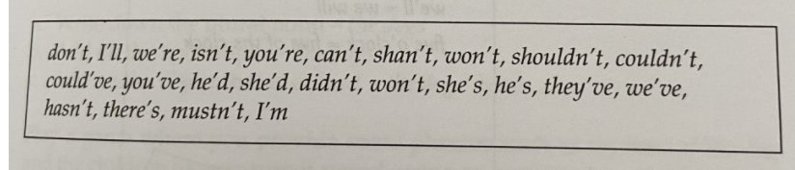
Task 3
Write this paragraph out again but change the contracted words to the full word(s)
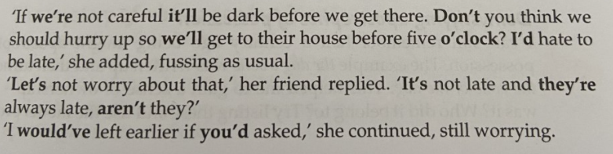

English
In English this week we are going to be writing a newspaper article about The New Fire Ceremony that took place in Aztec times. Watch this videos and take notes to learn about what happened.
https://www.youtube.com/watch?v=XsKO5z32uKc
and
https://www.bbc.co.uk/bitesize/clips/zyfygk7

Use a boxed up grid like this one and look at the teacher example to write your own newspaper report.
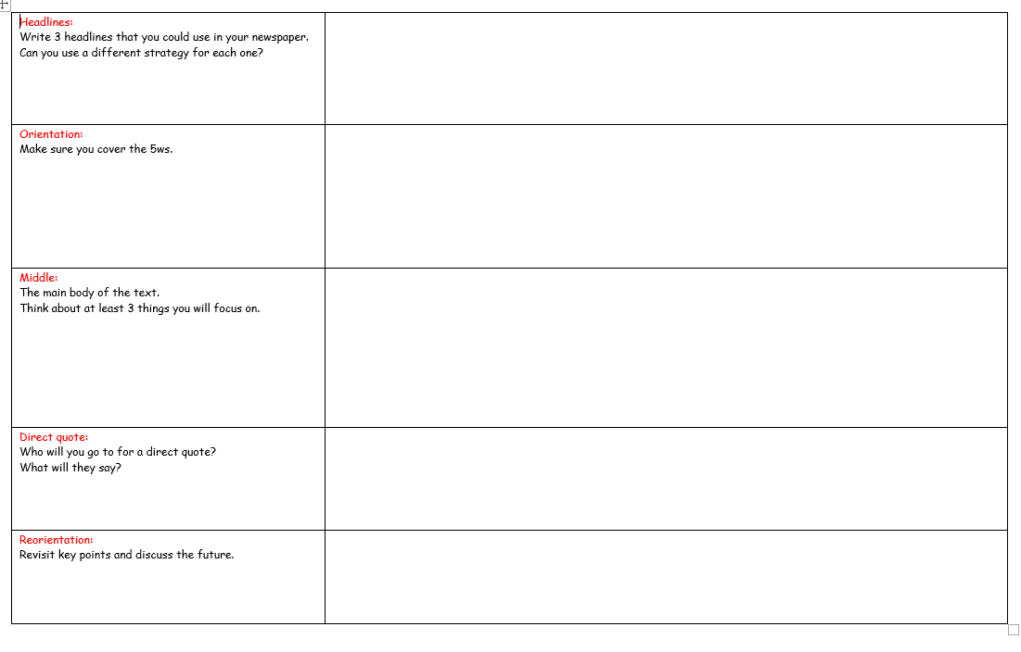
Here is an example for you to look at.
Headline is in blue.
Orientation and reorientation are in red.
Main part of text is in black.
Direct quote is in green.

FABULOUS FIRE GOD STARTS THE NEW CALENDER.
On an unusually cold summers night (June 12th 1345), the Aztec skyline was alight with colour once again as the Fire Priest started our wonderful New Fire Ceremony underneath the pyramid temple.
Fifty-two years on from the last one, the New Fire Ceremony was held last week. Crowds gathered excitedly and the atmosphere around the great pyramid was electric as the Fire priest started to generate new beginnings.
Only hours earlier, the Aztec people were ordered to put out their fires that had been kept ablaze year after year. Although some people were worried, they didn’t want to be the next human sacrifice so did as they were told.
Late into the evening, the Fire priest finally ordered the runners to light their flames and run like the wind around the kingdom. As people watched in astonishment, these elite athletes took no time at all to bring the light and much needed heat back to the surrounding villages.
The almighty Fire Priest was keen to tell us all about this magnificent event:
“It was a real pleasure, as it always is, to start the main fire. Although some Aztecs don’t agree with the human sacrifice that goes with this event, it is an essential part of our great history. Now all the fires have been relit-and the Gods are satisfied-the new cosmic era can begin!”
Finally, as the Aztec community still celebrate this momentous, vital moment in our calendar, people are looking to the future and a prosperous and safe time for all of us. Let the fires burn bright.

Science
In science we are looking at how exercise can change our heart rate. Complete your own investigation to see what happens to your heart rate when you exercise. Take your pulse before and after exercise and record your results using the prompts below.
Use this video to help you understand how and where to take your pulse.
https://www.medicalnewstoday.com/articles/258118#finding

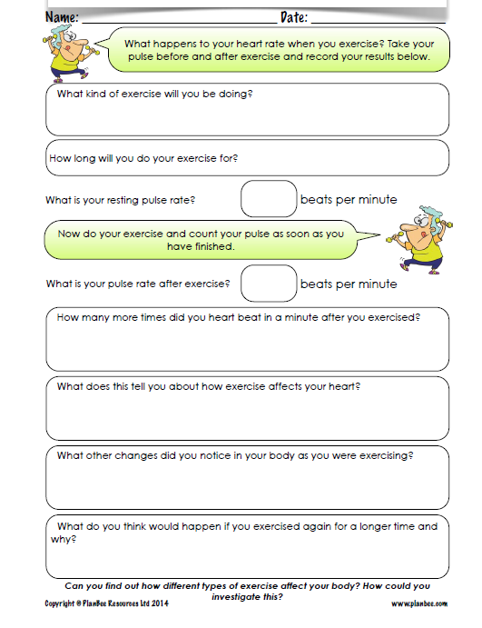

Guided reading
Read the text and answer the questions below.


