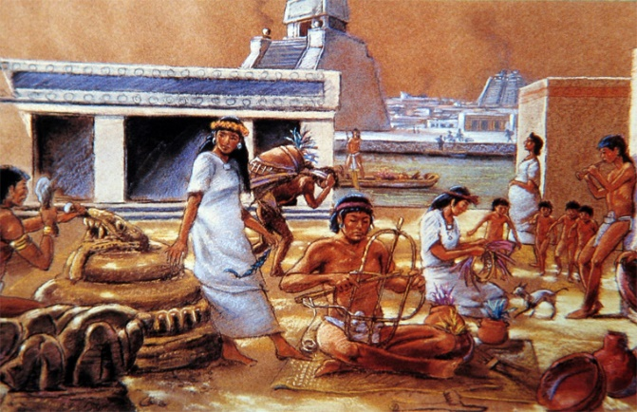
History
Thursday 21st October 2021
What was daily life like in Aztec times?

Take a look at the following website about Aztec times and read the information about daily life.

https://www.ducksters.com/history/aztec_empire/daily_life.php

Can you create a poster divided into four sections with the headings: Food, Home, School and Clothes? You can draw pictures and add notes or write a paragraph of information for each heading.

