Wednesday 20th October 2021
Do you know the dangers of alcohol and drugs?
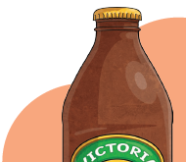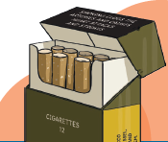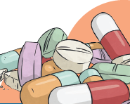

As part of our PSHE work this term we have been learning about harmful substances, such as alcohol, tobacco and drugs. This week we are building upon previous knowledge about these substances and thinking about a range of real-life scenarios.
Can you use the Alcohol and Drugs Discussion Cards to work with someone at home to consider the risks, dangers, pressures and choices you might have now or in the future when it comes to responding to certain situations involving alcohol or drugs?
There is no need to record anything for this session, just have a good chat about the different scenarios.

