RE
Wednesday 20th October 2021
Following our visit to Coningsby St Michael’s church last week can you complete the following activities?

Can you label the different parts of the church?
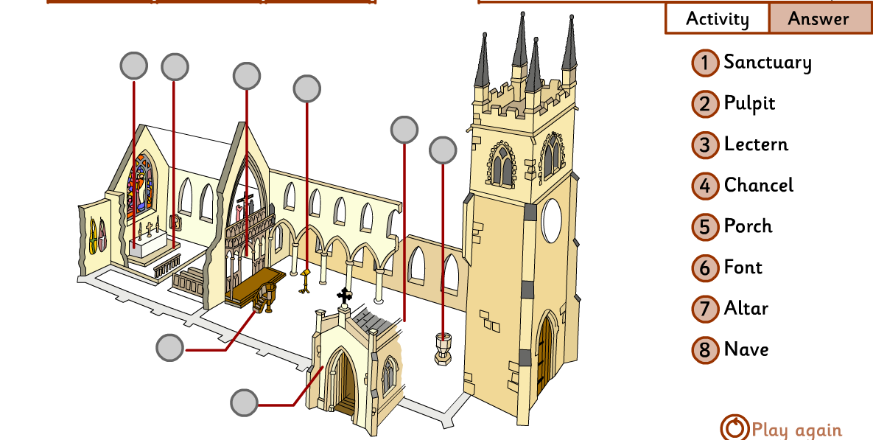

Now can you choose from the images below and explain how the objects in church show what Christians believe about God?



