Monday
Please look through the slides for Monday on the Maths wk 7 document and complete the task.

Extension
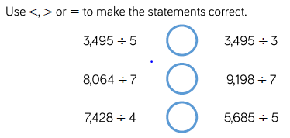
Challenge
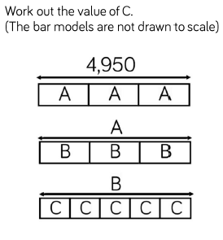

Remember to complete the rapid recall work as well.
Spend at least 5 minutes on Times Table Rock Stars

Tuesday
Please look through the slides for Tuesday on the Maths wk 7 document.

Task
Choose a divisor to explore.
Write down what you expect to find out and then see if you are correct.
Divide 3 digit numbers by your chosen divisor to explore

Extension
Use number 123 and divide by 2, 3, 4, 5, 6 etc.
Is this the same for other consecutive numbers?

Challenge
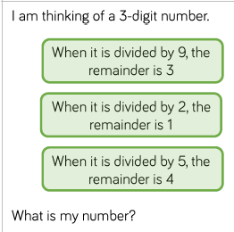

Remember to complete the rapid recall work as well.
Spend at least 5 minutes on Times Table Rock Stars

Wednesday
Please look through the slides for Wednesday on the Maths wk 7 document.
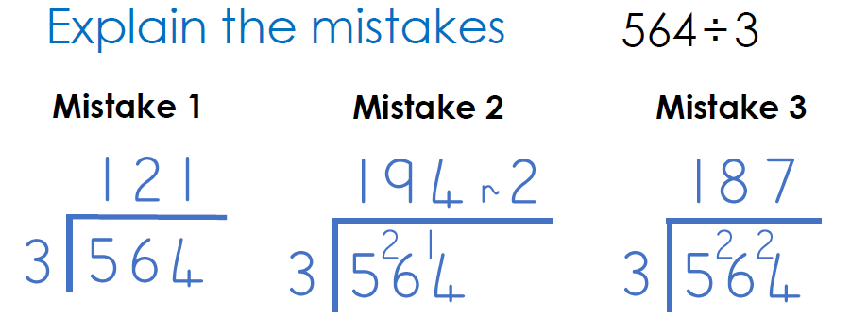
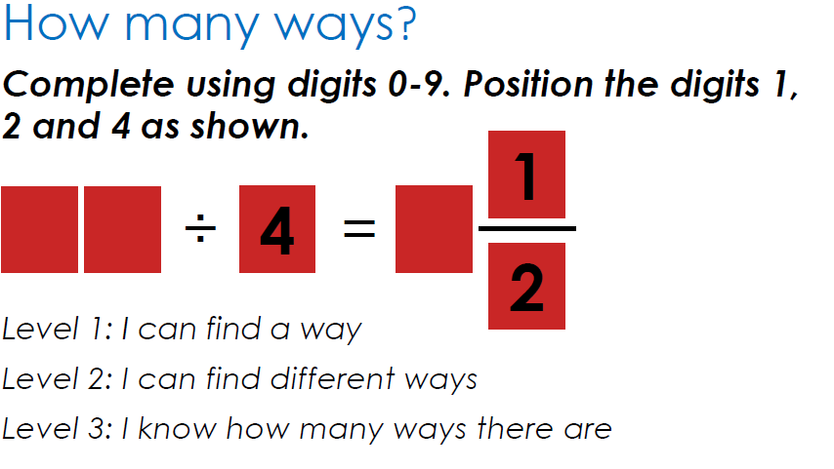

Remember to complete the rapid recall work as well.
Spend at least 5 minutes on Times Table Rock Stars

Thursday
Please look through the slides for Thursday on the Maths wk 7 document and complete the task.
Challenge

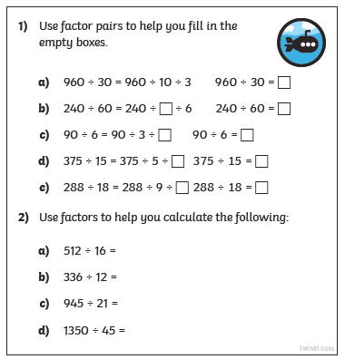
Remember to complete the rapid recall work as well.
Spend at least 5 minutes on Times Table Rock Stars

