SPAG
This week we are looking at apostrophes for both contracted words and possession. Have a look at the videos below to help you understand how each are used.

https://www.bbc.co.uk/bitesize/topics/zvwwxnb/articles/zcyv4qt
https://www.youtube.com/watch?v=dcDEAKkIVpc

Task 1
Using these phrases, change them around so that possession is shown.
- The bike of the girl. E.g. The girl’s bike
- The jewels of the queen.
- The tyres of the car.
- The food of the 4 cats.
- The changing room of the girls.

Task 2
Write these sentences out again and place an apostrophe in each one when needed.
- The girls walked to school.
- The girls bag was missing.
- The teams scored two goals each.
- The cats whiskers were long and silky.
- The dragons grew bored of terrifying villagers.
- The torchs battery had run down.

Task 3
Write these sentences out again and place an apostrophe in each one when needed.
This time, give a reason for every time you use one. Is it for possession or contraction?
Mrs Jenkins didnt mind cutting the donkeys beard because it wouldnt look good.

Bobs dog growled as it couldnt chase the cats owners.

Youre about to eat the dogs dinner.

All the soldiers rucksacks were stolen.

Well never find the pirates treasure.

English
Last week we wrote a newspaper report to inform people about the New Fire Ceremony. In English this week we will be writing another article. First you will need to pick an image to write about from the ones below and then place some ideas in a boxed up grid. Once you have done this you will then need to write your article. Don’t forget to include:
- Headline
- Orientation
- Main body
- Direct quote from someone that was there
- Reorientation
- Image and caption
Create a boxed up grid like this one to generate your ideas for writing your article.
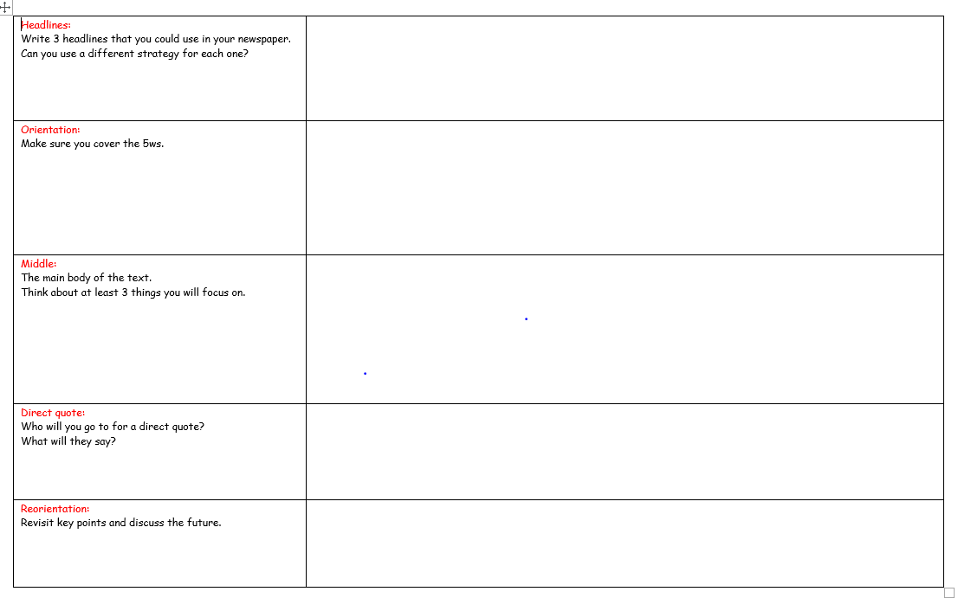
Choose one of these images to create your article about.
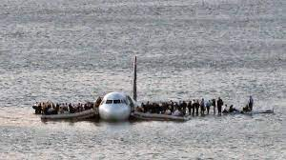
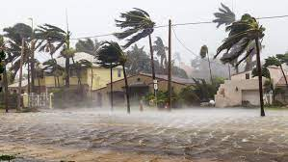
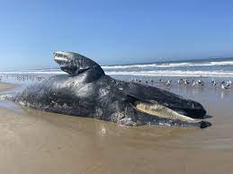

Science
If you can, you will need to conduct some research with an adult and create a poster about the information below:
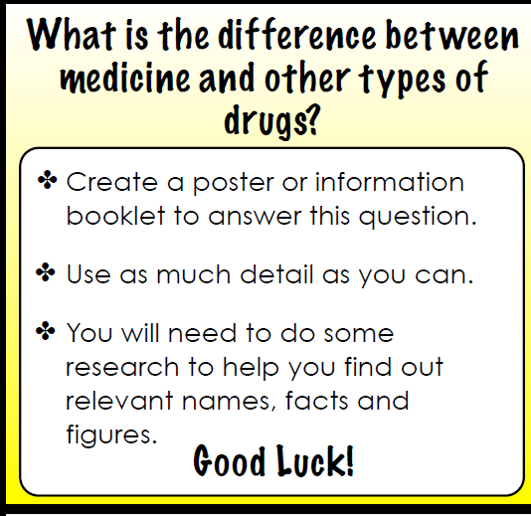

Guided reading
Spend some time reading a book at home. Also have a go at these inference questions below:

Text 1
The birds sat on the trees and sang so sweetly that the children used to stop their games and listen to them.

One day a Giant came back. When he arrived he saw the children playing in
the garden.

“What are you doing here?" he cried in a very gruff voice and the children
ran away.

"My own garden is my own garden," said the Giant. "Anyone can understand that, and I will allow nobody to play in it but myself." So he built a hight
wall round it and put up a notice-board:

TRESPASSERS WILL BE PROSECUTED.

Q1
What can we infer about the Giant's character? Use the text as evidence.

Text 2
Splat! The coleslaw tub fell right in front of Mum's feet as she opened the fridge door. Splat! The butter, milk and leftover lasagne followed quickly behind.
Mum stopped and turned round, her dripping wet coat making an even more mess on the floor. She'd arrived just in time to miss the worst of the storm.
What an earth could have happened? It looked like the house had been burgled by a hungry visitor.
She turned around to look at the kitchen bench. Empty pizza boxes, a sharp knife, a pool of coke flowing dangerously near the edge. She scooped up a gooey red liquid and tasted it. Mmm! definitely jam; George's favourite. But George was at scout camp, He wasn't due home until tomorrow morning. Besides, there was far to much food for one person alone. Without making a sound, Mum silently inched towards the kitchen door.
Q2
What conclusion had Mum come to?
Give two conclusions, referring to the text in your answer.

