Monday
Please look at the slides, dated 15.11.21,for multiples and common multiples and then practise finding common multiples of the numbers shown in the task.

Eg first 3 common multiples (the multiples they share) of 2 and 4.
Multiples of 2:
2, 4, 6, 8, 10, 12
Multiples of 4:
4, 8, 12

The first 3 common multiples of 2 and 4 are 4,8 and 12.
Extension and challenge
1,
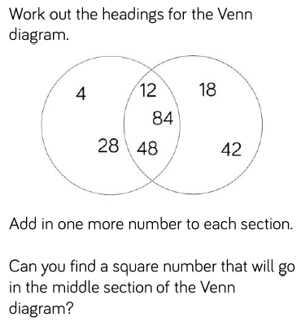

2,
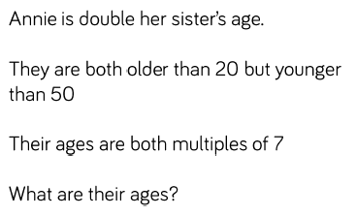
3,
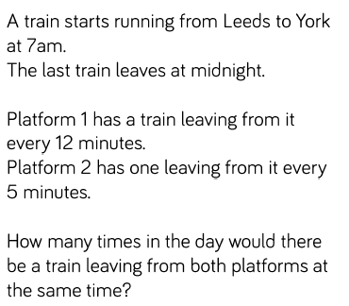

Tuesday
Factor multiple chains.
Please look at the slides dated 16.11.21.
For more information follow this link https://nrich.maths.org/5578
Please use the spread sheet attached to look at examples.

Wednesday
Prime numbers
Please look at the slides dated 17.11.21

Use this number grid to circle the prime numbers that you find.
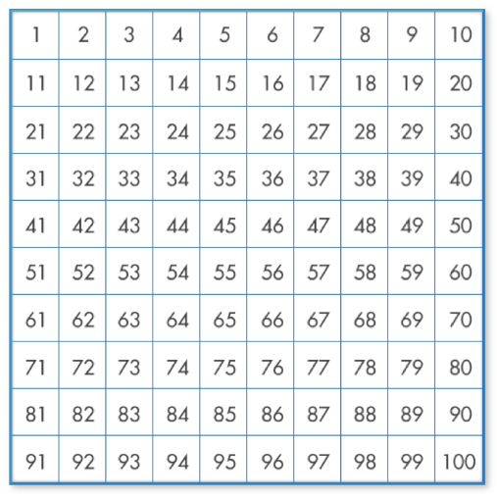
Thursday
Square and cubed numbers
Please look at the slides dated 18.11.21
Please complete the table
 |  | 1 |  |  | 1
 |  |  |  |  | 8
 | 3 x 3 |  | 3³ |  | 27
 | 4 x 4 |  |  | 4x4x4
 |  | 25 | 5³
 |  |  |  | 6x6x6
8²

Challenge


