SPAG

We have been looking at different sentence types in class. Use the website below to understand what a simple, compound and complex one is.

https://www.bbc.co.uk/bitesize/guides/zxqnfg8/revision/1

We have also been using CLAP to understand when we need a comma.

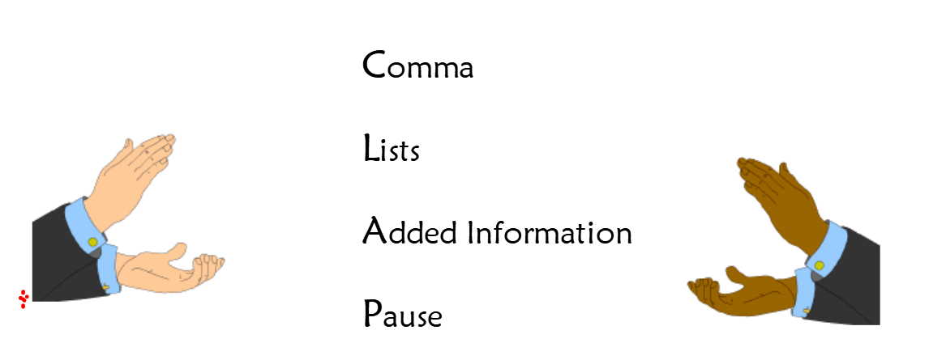

Using the image below can you create some sentences using commas in a list?

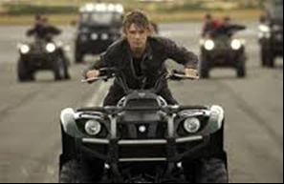
Example:
Alex was focused on the road ahead as he was being chased
by: quad bikes, bulletproof vehicles and even a stealth helicopter.

Using the image below can you create some sentences using commas for added information?

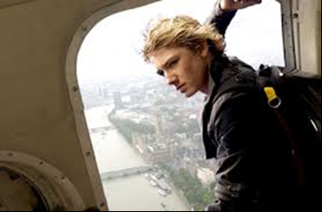

Example:
Alex, who was hanging expertly out of the helicopter, gave one last look to the crew before taking the leap of faith.

Using the image below to create some examples of using commas for a pause.
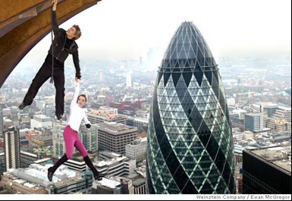

Example
As the wind blew wildly around them both, Alex grasped the girls hand tightly.

Can you now create one of each using the new image below?

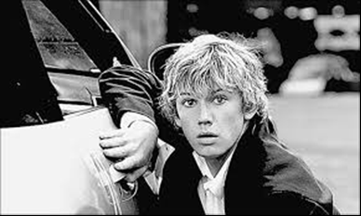
List:

Added information:

Pause:

English
In our book, Storm Breaker, Alex finds himself trying to escape from so bodyguards whilst trying to find his uncle’s car. Use the link below to look at what a scrapyard looks like.
https://www.youtube.com/watch?v=08vuXspuhWg

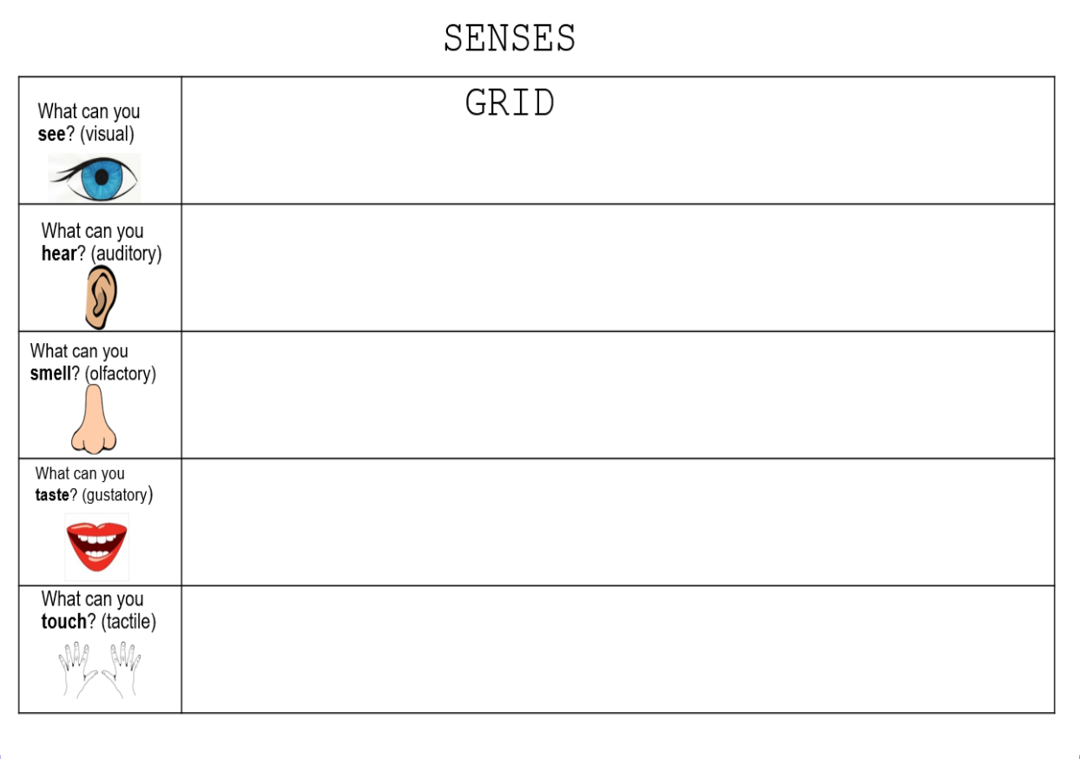

Use a grid like the one above to complete a senses grid on what it would be like if you were Alex and were in the middle of a scrapyard.

Now look at the modelled example for a story opening set there. Can you also write your own story opening using a setting description?

Angrily, the enormous crane's mouth swallowed its next victim, spitting out all it couldn’t chew. This place was a graveyard for cars. Eerie! The stench of oil, which burnt Alex’s nostril hair, was enough to put anyone off their lunch. He was fully aware this might be his last place of rest! Piles of cars lay next to each other like fallen soldiers on a battlefield.
Running frantically for cover, his body pressed tightly against a crushed car. Tasting rubber briefly reminded Alex of a steak Jack had overcooked for him only a day earlier. He needed to re-focus and think of a plan.
Suddenly, lights flickered illuminating him clearly to his enemies. Before your average 14 year old could blink, Alex dashed into the safety of another car…or was it?

Task 2 English

We are also writing our own short stories where Alex finds himself in a tricky situation. First complete a story map like the one below:

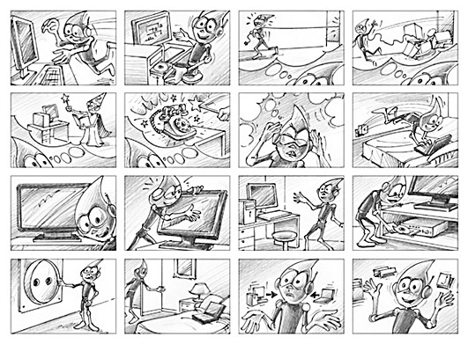
Then look at how a story map can be made into a short story. This is just the start of one to show you the level of detail expected.

Tick tock, tick tock! The room felt smaller than a rabbit's burrow. A chink of light broke through the tiny crack of the locked door. Alex was in trouble…big trouble. Nervously he scanned the room for clues…an escape route maybe. Tick tock, tick tock. Next to the chair, which his hands were tied tightly to, a bomb stood proudly waiting to explode. He had been in many tricky situations before although this time it felt different. Tick tock, tick tock. “Help, is there anyone there?” The words travelled nowhere and bounced off the cold, damp walls smacking Alex in the face. Because he could see the detonation time (3 minutes, 6 seconds), he suddenly realised that feeling sorry for himself wasn’t going to work.
Another minute had elapsed when Alex felt into his back pocket; he found the Penknife that his Uncle Ian had once given him for his twelfth birthday was waiting to be used. Quickly grabbing it, he started to tear and rip at the thick, heavy rope that was wrapped like a coiled snake around his hands.

Write your own short story involving Alex Rider.

