Wednesday 1st December 2021
Is it ok?

In PSHE this week we are discussing whether certain situations are ok or not. Are the situations reasonable or unreasonable, do they make us feel uncomfortable and what should we do about it?

You do not have to record anything for this learning but please discuss the scenario cards attached with an adult and talk about what you would do and who you could talk to.
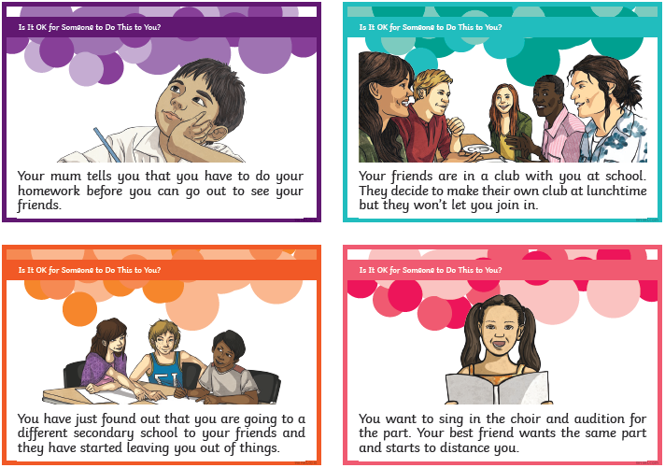
(A full set of discussion cards is on the school website with the home learning.)

