Monday 29th November
Please look at the slides for 29.11.21 and then using strips of paper fold to make your own fraction wall showing 1, ½, 1/3, ¼, 1/5, 1/6, 1/8
Please complete the rapid recall slides as well for this day.
Tuesday 30th November
Please look at the slides for 30.11.21.
If you have lego then please create a shape using 12 of the same size blocks. These must be 3 different colours. If you don’t have lego then use any objects or draw a shape with 12 squares of 3 different colours.
Imagine your shape is a whole and then record the fraction of the shape that is each colour eg ½ of my shape is red.
Then order the colour by size eg red>green<blue
Repeat using different amounts of colours and different amounts of cubes.
Extend to 4 different colours

Please complete rapid recall slides for this day as well.

Wednesday 1st December
Please look at the slides for 1.12.21
Complete the task on the slides
Extension
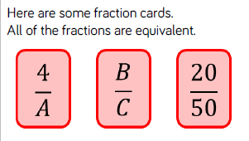
Complete the rapid recall slides for this day as well.
Thursday 2nd December
Please look at the slides for 2.12.21
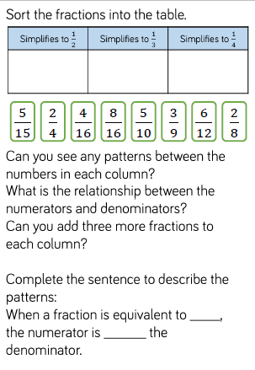
Please complete the rapid recall slides for today as well.

Friday 3rd December
Please look at the slides for 3.12.21
Complete the task on the slides
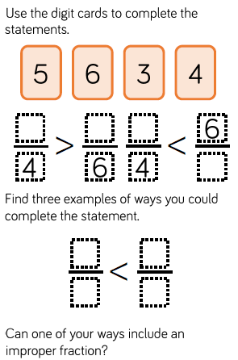

Please complete the rapid recall slides for this day as well.

