English and science home learning.
In SPAG we will be looking at determiners. Watch this video to help you understand what they are.
https://www.youtube.com/watch?v=B8MnOXgX0Kk

SPAG TASKS.
Write this section out again placing a determiner in each space where there are question marks.

???? soldier rushed to ???? road as ????? ambulance pulled up.
Look at ????? man stealing ????? handbags.
I like ????? Scarf and ?????? Rings.
???? dog growled at ?????? cat.
????? snakes swim.

Task 2
Read the paragraph below, it doesn’t make sense because the wrong determiners have been used each time before the nouns. Can you first find them, and then replace them with a more suitable one.

Each baker grinned as he turned a pie over. They were cooked on a sides. Three pie had the beautiful crust. The two cat sidled up to our safe hiding place, the eyes scanning for scraps. All passing dogs stared in at that door. Its cook glared at his animals.

Task 3
Some determiners have to have a or an before them. If the word starts with a vowel, a, e, I, o, u then it needs to have an before it.
e.g. an apple
Look at the words below and write down whether it should be a or an before each one.
Ant, apple, balloon, cup, dog, elephant, engine, frog, giraffe, horse, ice cube, igloo, juggler, kite, lemon, mouse, newt, orange, owl, parrot, queen, rat, snake, telephone, underpass, umbrella, vest, weekend, zoo.
Can we add 3 of our own?

Task 4
Sometimes we need to decide if the determiner is it’s or its. We only use it’s when we are wanting to say it is. Look at the sentences below which one should be used each time?

I wonder if its safe to go outside.
Its going to rain on the dog so grab its collar.
Its tiny feathers were coloured red.
Do you know if its time to see its next programme

English
In English we will be writing an information text that tells people all about a made up animal.
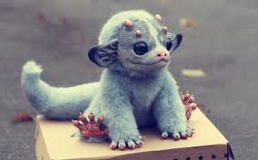

Use a boxed up grid like the one below to form some ideas about the creature above. Remember to be as imaginative as possible.
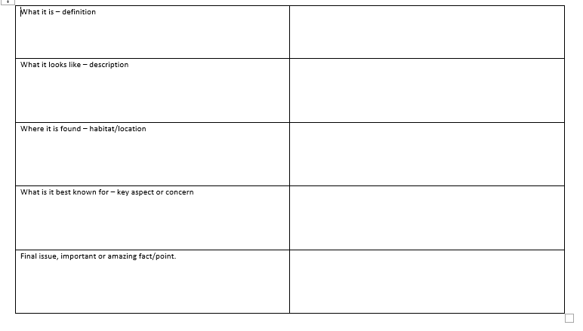

Once you have finished the grid create an information text about your creature. Don’t forget to use subheadings to separate different areas.

Here is an example of an opening that covers a definition and what it looks like to help you with your ideas.

Muggles

A Muggle is a small furry animal closely related to the more common Miggle.

Have you ever wondered what it would be like to own the world’s deadliest creature? Don’t be fooled by its cute exterior, a Muggle can kill you in a heartbeat! Scary! As cute as a child’s teddy, its venomous, yet slightly ugly, dimples that sit on the top of his head can shoot poisonous venom to targets that are as far as 30 feet away! Most Muggles are brown in colour, but some females can have more of an orange tinge in certain lights. Similar in size and weight to a domestic cat, a Muggle can be picked up easily by humans.

Science
In science we will be conducting an investigation to see what happens to the size of a shadow when you move a light source further away from an opaque object. The diagram below show using a piece of card but you could use anything that is opaque like a Lego character.
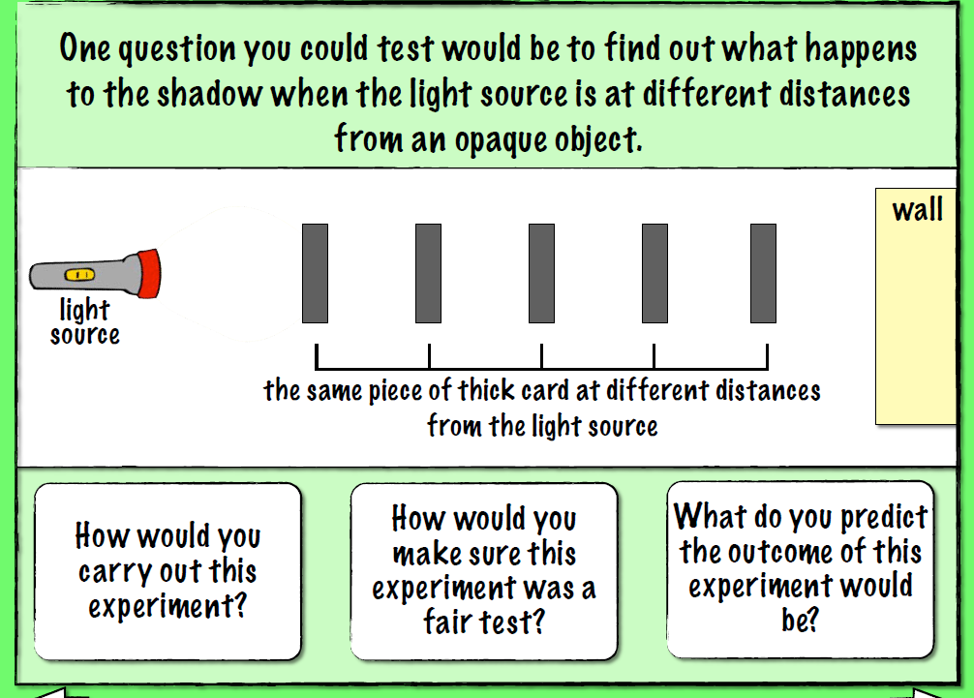

Conduct the investigation but make use you only change one thing each time, the distance the light source is from the object, and record your results in a table like this one. You will also need to write a conclusion, what did you find? You could even take some photos of your investigation.



