Maths – week beginning 4.1.22
Subtracting fractions

4.1.22
How do you subtract fractions?

Work through the slides and complete the task on the slides.
If you are unsure then this video might help.
https://www.bbc.co.uk/bitesize/articles/z42vgwx
Watch the video – part b – subtracting fractions

5.1.22
Can you subtract fractions?

Work through the slides and complete the tasks on the slides including the plenary task.
Watch this video if you are unsure
https://www.khanacademy.org/math/cc-fifth-grade-math/imp-fractions-3/imp-adding-and-subtracting-fractions-with-unlike-denominators/v/subtracting-small-fractio
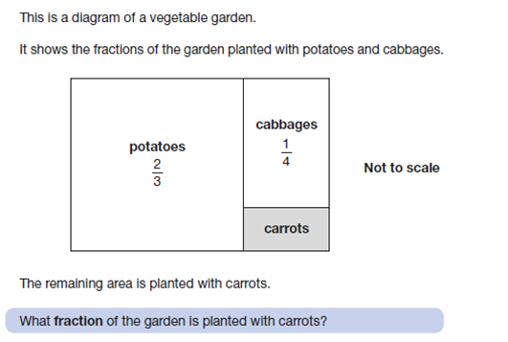

6.1.22
Can you subtract a proper fraction from a mixed fraction

Work through the slides and complete the tasks on the slides.
Watch the following video to support as well.
https://www.youtube.com/watch?v=UuEugzWpkSg

Extension questions
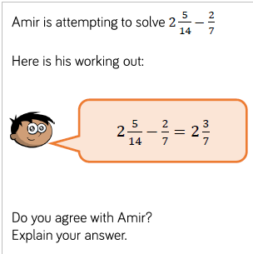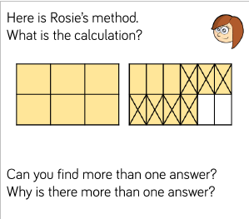

7.1.22
Can you subtract a mixed number?

Work through the slides and complete the tasks on the slides.
Look at method 2 and 3 following this link to support:
https://www.bbc.co.uk/bitesize/articles/zhs9d6f

