10.1.22
How do you subtract a mixed number?

Work through the slides and complete the tasks on the slides.
Look at method 2 and 3 following this link to support:
https://www.bbc.co.uk/bitesize/articles/zhs9d6f

Complete the task on the slides.

Extension task
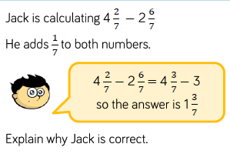

11.1.22
How do you multiply a fraction by a whole number?

Watch the following video
https://vimeo.com/415879394
Then work through today’s slides.
Complete this diagrams
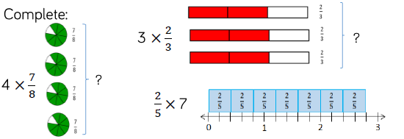
Complete the task on the slides.
12.1.22
Can you multiply a whole number by a mixed number?

Watch the following video
https://vimeo.com/420244296
Complete today’s slides.

Complete these tasks
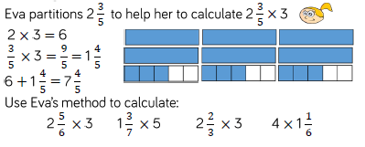
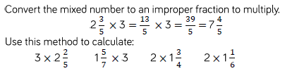

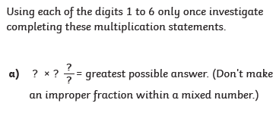

13.1.22
How do you multiply a fraction by a fraction?
Watch the following video before working through today’s slides.
Complete the task on the slides.
The complete these tasks
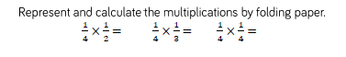
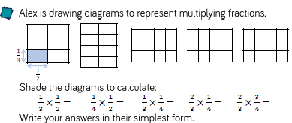

14.1.22
Can you multiply two fractions together?

Look at today’s slides and complete the task on the slides.
Challenge


