17.1.22
Can you multiply 2 fractions together?

Watch the following video to find out how to multiply fractions together.
https://vimeo.com/415879473

Look at the slides for today and complete the tasks.

Challenge
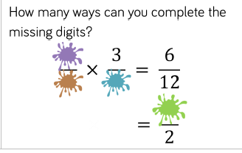

18.1.22
Can you divide unit fractions by an integer?
Watch the following video
https://vimeo.com/415879537

Look at today’s slides and complete the task.
Task
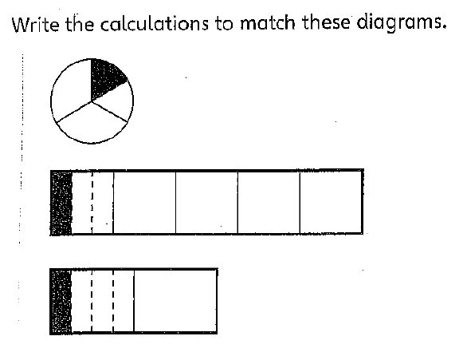
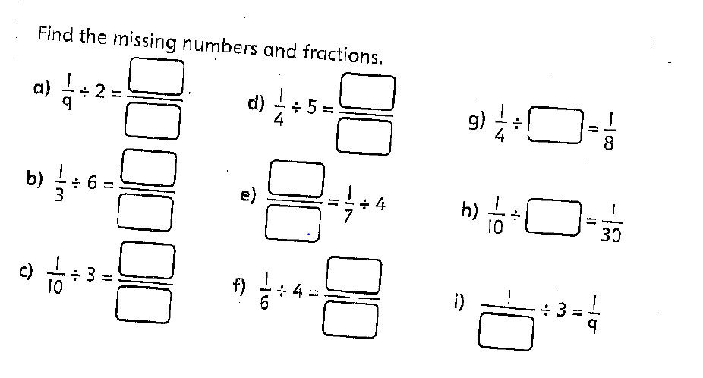
Challenge
Find 6 different ways to make the calculation correct.
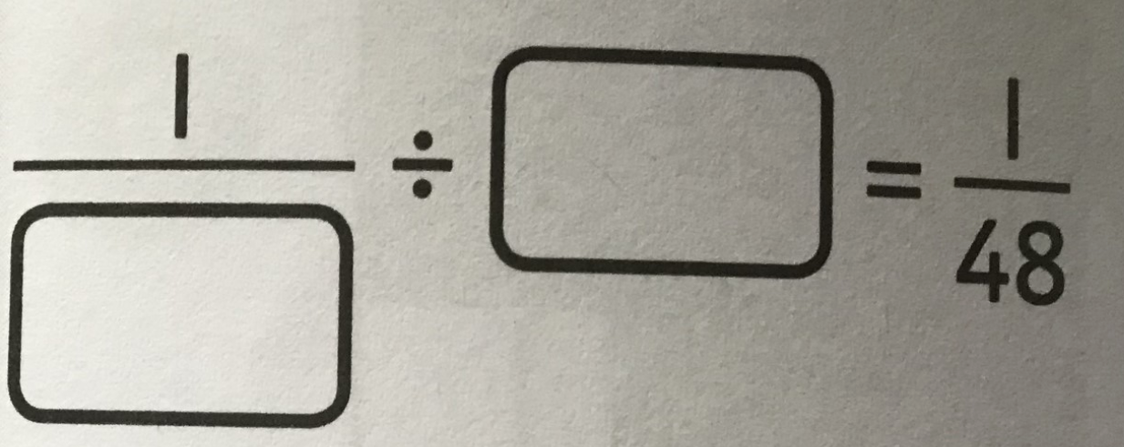

19.1.22
Can you divide a fraction by an integer?
Re-watch yesterday’s video if needed.
Look at the slides for today and complete the task.

Task
What is the pattern?
Complete one row at a time and write down what you notice each time.
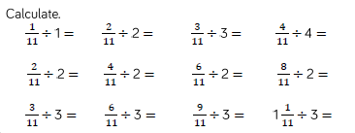

Extension
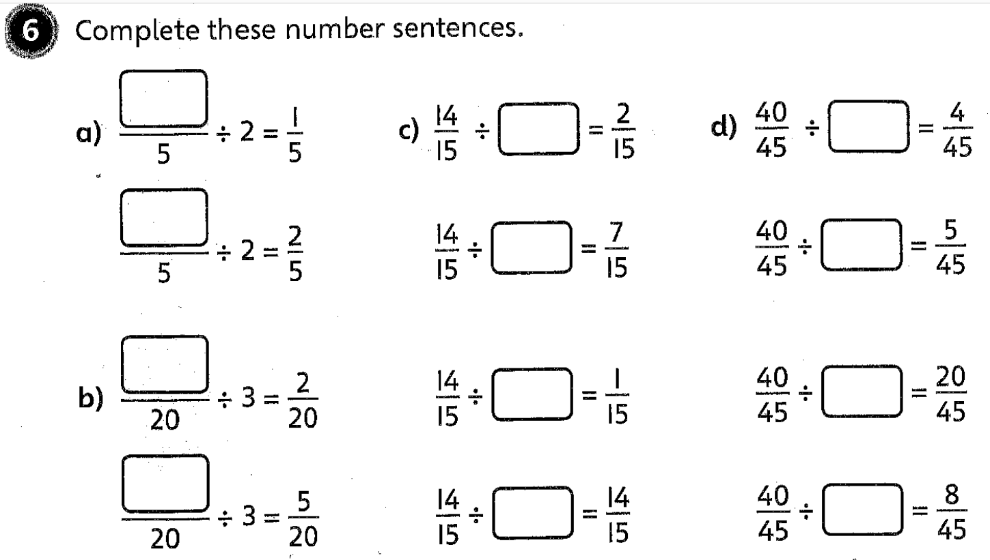

Challenge
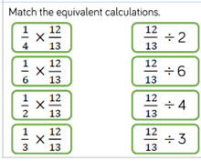

20.1.22
How do you divide a fraction by an integer?
Look at today’s slides and complete the task.
Task
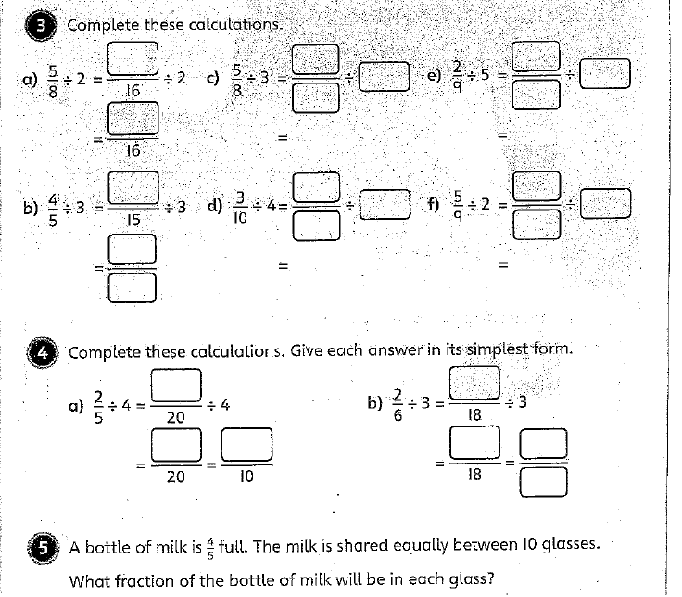
Challenge
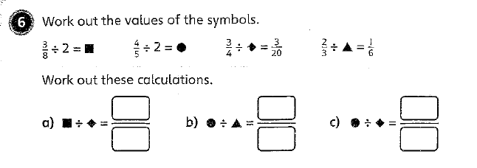
21.1.22
What is a decimal?
Look at today’s slides
Complete the task using the place value chart below.
Ones | Tenths (1/10) | Hundredths (1/100) | Thousandths (1/100)

Extension
Put the numbers in ascending order.

Challenge


