24.1.22
How do you partition a decimal number?
Look at today’s slides and complete the task.
Use this copy of the Gattengo chart to support.
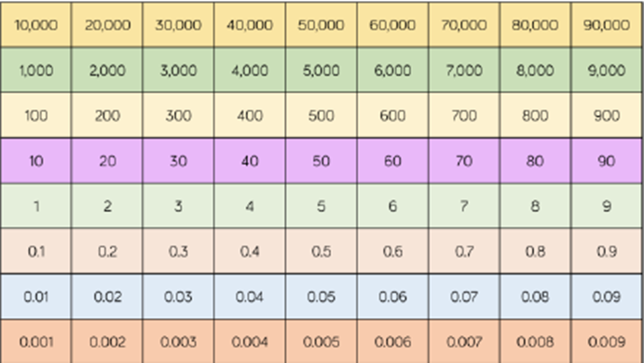
Extension
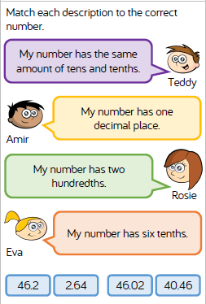

25.1.22
What happens when you multiply by 10, 100 and 1000?
Follow the link and watch the video titled multiply by 10, 100 and 1000.
https://whiterosemaths.com/homelearning?year=year-6
Look at today’s slides and complete the tasks on them.

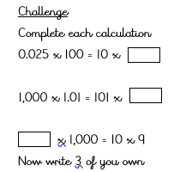

26.1.22
How does the value of each digit change?
Look at today’s slides and complete the tasks.

Task
a) 2.5 x 10 = b) 2.5 x 20 =
c) 2.5 x 200 = d) 2.5 x 2,000 =

e) A builder orders 400 bricks. One brick costs £1.50. What will be the cost of the order?

f) There are 500 of each type of brick. What is the total mass of all the bricks?

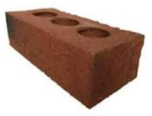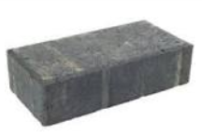
A = 0.8 kg each B = 1.2kg each

g) Bella says that when you multiply 5.02 by 100 you get 520. Explain her mistake.
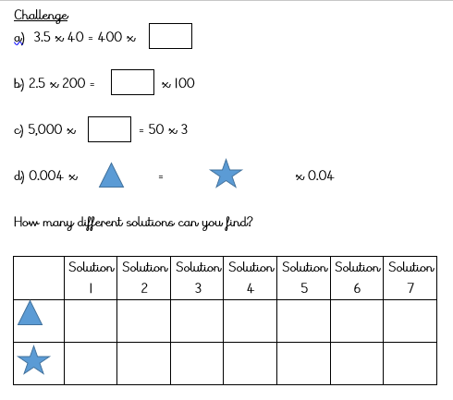
27.1.22
What happens when you divide by 10, 100 and 1000?

Look at today’s slides and complete the tasks
 | ÷ 10 | ÷ 100 | ÷ 1000
30
3 kg
 | 0.9
 |  |  | 9
 |  | 9.09
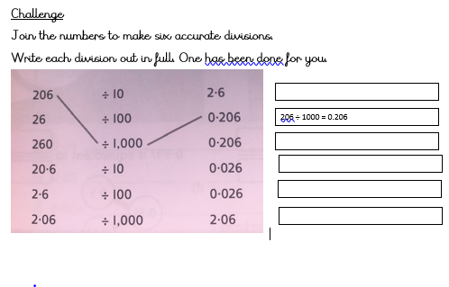
28.1.22
How does the value of each digit change?
Look at today’s slides and complete the tasks on them.



