31.1.22
Can you add decimals?
Look at today’s slides and complete the tasks on the slides.
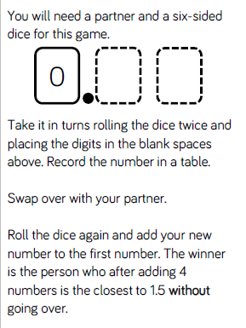
Extension
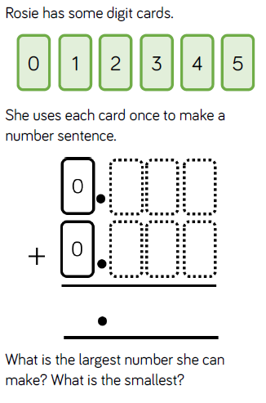
Challenge
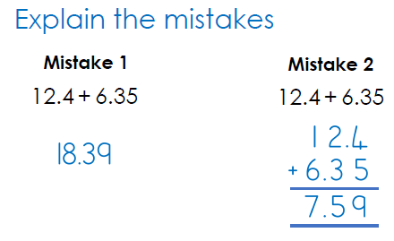
1.2.22
Can you subtract decimals?
Look at today’s slides and complete the tasks on them.

Challenge
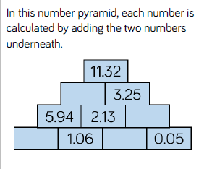

2.2.22
How do you subtract a decimal from a whole number?
Look at today’s slides and complete the tasks on them.
Challenge
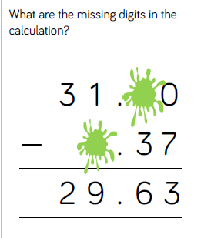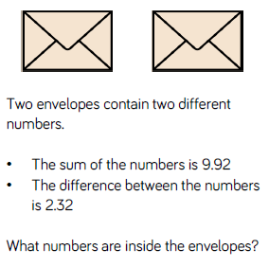
3.2.22
Can you multiply a decimal by an integer?

Watch the following video and complete the tasks
https://classroom.thenational.academy/lessons/multiply-a-decimal-number-by-a-whole-number-6mwpcd

Challenge
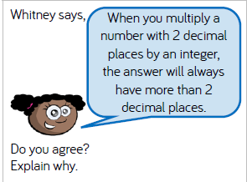
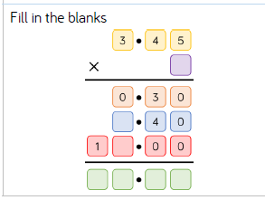

4.2.22
NSPCC Number day.
Play as many times as you can on Times Table Rock Stars to add points to our school competition.
Look at the powerpoint titled Maths in the working world.
Make a poster about a job that you would like to do or a job that one of your parents does. What maths is used in this job?

