Tornadoes
Tornadoes have often been popular weather phenomenon in stories. It was a tornado that dropped Dorothy into Oz in the Wizard of Oz. They are formed when warm, humid air collides with colder, dry air. When the cold air passes over the warm air, it normally causes a thunderstorm. About one in a thousand of these storms will become a super cell storm and a fifth of these will create a tornado.
On the 18th of May 1929, the Tri-State Tornado ripped through Missouri, Illinois and Indiana. It remains to this day the most devastating tornado to hit the United States of America. The trail of destruction went on for 219 miles and left thousands of people without homes. 2,027 people were injured and 695 people lost their lives. It lasted for around 3.5 hours in total.
The most deadly tornado recorded anywhere in the world was in Bangladesh on the 26th of April 1989. It killed nearly 1,300 people.

How fast can they get?
The wind can reach 300 mph, which is faster than a
formula 1 car.

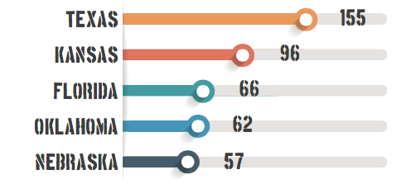
The United States has significantly more
tornadoes than any other country in the
world. The southern states get most
of their tornadoes between March and May.
The northern states get most between June and August. There are an average of 1,235 tornadoes per year in the United States. This chart shows the average number for each of the top 5 states.

How long do they last?
Most tornadoes last less than 10 minutes. However, they can last over an hour.

