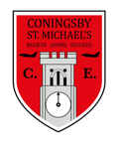 | Class:  4Y and 4E | Learning question for the term:  Can you walk like an Egyptian? |  | Science focus for the term:  Sound | English text for the term;  Gold in the Grave by Terry Deary |  | RE focus for the term:  How do Muslims worship?
At Coningsby St Michael’s, we believe all areas of the curriculum are important. This term we would like you to choose a minimum of 4 activities from the grid below, as your homework tasks. Other than reading, spellings and times table practise, no weekly homework will be set. We hope that this style of homework will encourage everyone to take part and give parents a chance to become more involved in working with their children on fun, creative and exciting activities. Children’s completed homework tasks will be recorded and monitored. Children who successfully engage in home learning tasks will be rewarded at school.
Please ask parents, family members or friends to join in and have fun. You can you use your homework task book for writing tasks, evidence logs, saving photos or collecting any other evidence of your learning. When each task is completed you need to bring it in or take photographs. The photographs do not have to be printed and can be sent to your class teacher using Class DoJo. When evidence is seen we will tick off your tasks and record your choices. We are hoping by giving everyone choices that a selection of activities will be completed by pupils with support from family members. Teachers will speak to parents if children are not engaging in home learning activities.
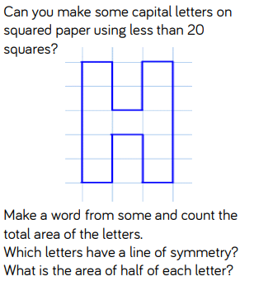  Maths |  |  | English  Find out as much as you can about Tutankhamen. Now write an acrostic poem about him.  T  U  T  A  N  K  H  A  M  E  N | Science  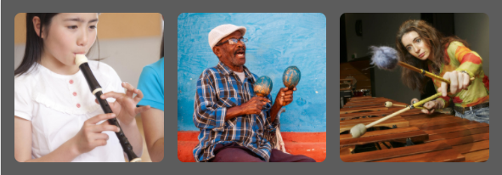  Look at these 3 pictures of musical instruments being played. Which is the odd one out? Why is it the odd one out? |  | 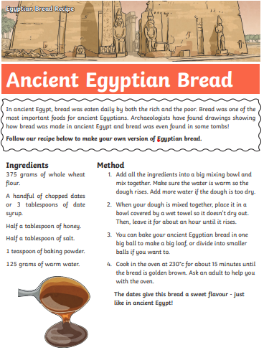  DT  Use the following recipe to make some Ancient Egyptian bread
RE  https://www.bbc.co.uk/bitesize/topics/zpdtsbk/articles/zjc2bdm  Using this link, read the information about Ramadan. Create a leaflet about Ramadan. |  |  | History  Find out about one of the Ancient Egyptian gods. Now create a poster explaining all about them. | SPaG  How many words can you find that have the suffix ‘-ture’. For example:  - mixture  - adventure  Now choose 5 words and write a sentence for each. |  | Art  Using what you can find at home (recyclable materials), have a go at creating an Ancient Egyptian pyramid.
Maths  An oblong has an area of 24cm². What could the lengths and widths be? |  |  |  | English  Write a news script for the robbery of Tutankhamen’s tomb from ‘Gold in The Grave’. Now get someone to film you reading your news report.
Reading – Children should be encouraged to read every day. Please spend 5 or 10 minutes listening to your child read and discussing their books. |  |  |  | Maths – All children from Year 1 to Year 6 have all been provided with a log in for Times Table Rockstars or Numbots. Children should be completing at least 3x5 minutes each week.

