Year 4 Term 5 Curriculum
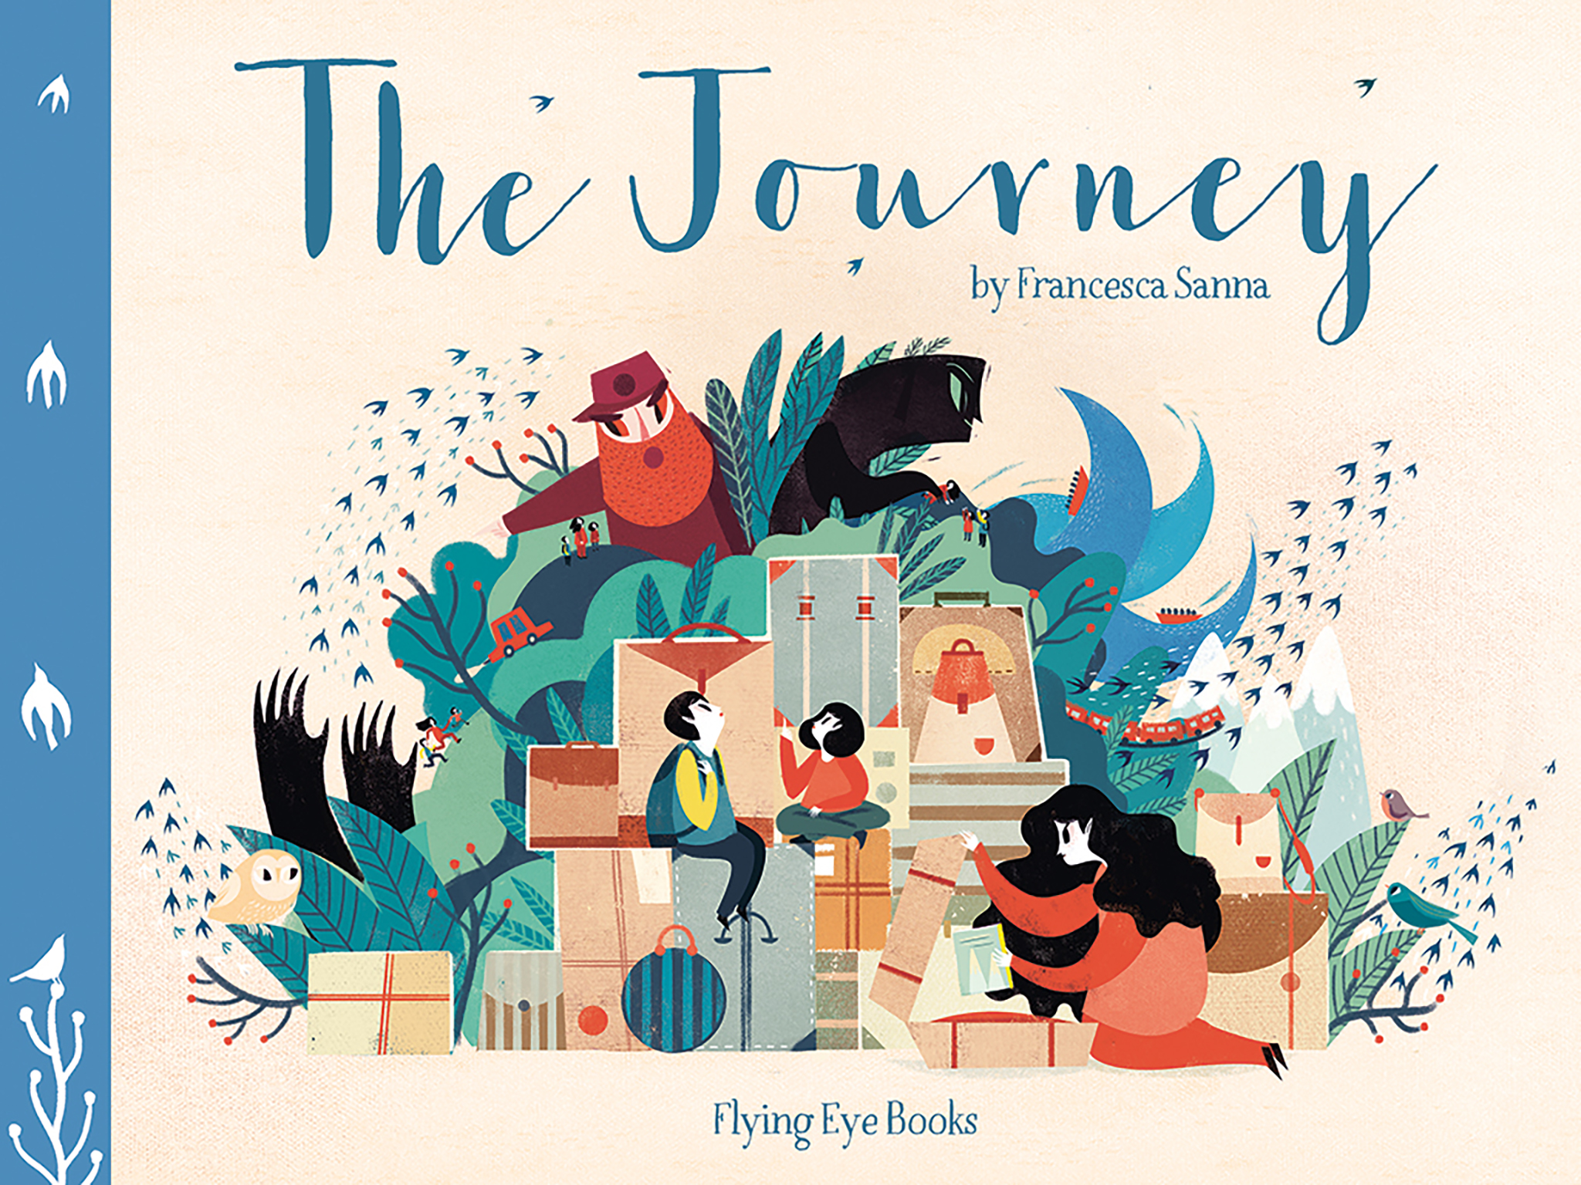
As Coningsby Mathematicians we will:

Be writing, ordering, rounding and comparing decimals.
Be using halves and quarters.
Be ordering and estimating money.
Be converting pounds and pence.
Be adding and subtracting money.
Be finding change.
Be telling the time to 5 and 1 minute intervals
Be using am and pm and 24-hour clock.
Be converting between analogue and digital and vice versa.
Welcome back to our new term.

Please remember this term… Reading books and reading records in school every day. Homework will be set termly and the children have home learning books. Our PE days are Tuesday and Friday and please bring in PE kits on a Monday and take them home on a Friday.
As Coningsby Scientists we will:

Be classifying animals into carnivores, herbivores and omnivores.
Be constructing food chains.
Be identifying types of human teeth and their function.
Be learning how to keep teeth healthy
Be learning about the digestive system and the function of its basic parts.
As Coningsby Authors we will:

Be exploring the text ‘The Journey’.

From this we will be writing a narrative based around refugees and writing diary entries.

As Coningsby believers we will:

Be looking at what pilgrimage is and how followers of different faiths undertake a pilgrimage

Consider our school value of ‘Forgiveness.’
As Coningsby Historians we will:

Be learning about the invasion of Britain by the Romans.
Be learning about Roman roads and the places they linked.
Be researching the impact of Roman occupation on the people of Britain.
Be learning why Hadrian’s Wall was built.
Be learning about Roman Gods and Goddesses.
Be learning about Roman baths.
As Coningsby Artists & Designers we will:

Be using lines to create depth and texture.
Be using colours and lines to create shade and tints.
Be using lines to create movement
Be developing sketching techniques.
Be using lines and colour to create portraits in the style of Van Gogh.

