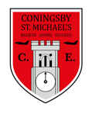 | Class:  4Y and 4E | Learning question for the term:  Why were the Romans so Powerful? |  |  |  | Science focus for the term:  Animals including Humans. |  |  |  | English Text for this term:  The Journey by Francesca Sanna
At Coningsby St Michael’s, we believe all areas of the curriculum are important. This term we would like you to choose a minimum of 4 activities from the grid below, as your homework tasks. Other than reading, spellings and times table practise, no weekly homework will be set. We hope that this style of homework will encourage everyone to take part and give parents a chance to become more involved in working with their children on fun, creative and exciting activities. Children’s completed homework tasks will be recorded and monitored. Children who successfully engage in home learning tasks will be rewarded at school.
Please ask parents, family members or friends to join in and have fun. You can you use your homework task book for writing tasks, evidence logs, saving photos or collecting any other evidence of your learning. When each task is completed you need to bring it in or take photographs. The photographs do not have to be printed and can be sent to your class teacher using Class Dojo. When evidence is seen we will tick off your tasks and record your choices. We are hoping by giving everyone choices that a selection of activities will be completed by pupils with support from family members. Teachers will speak to parents if children are not engaging in home learning activities.
Maths  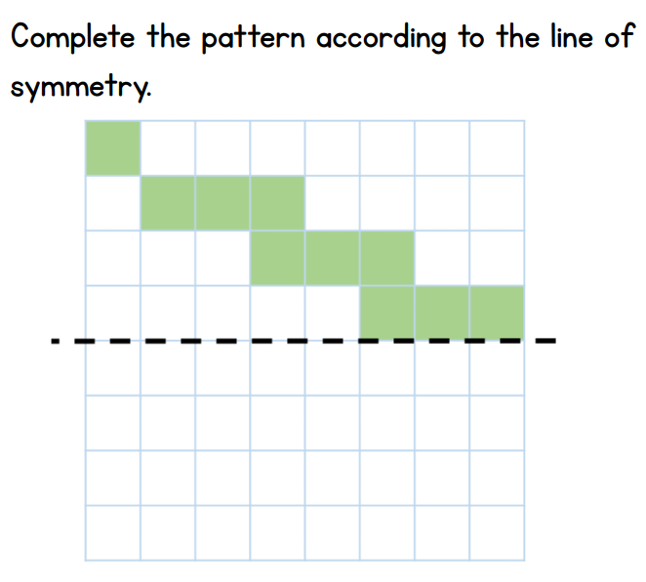 |  |  |  | Maths  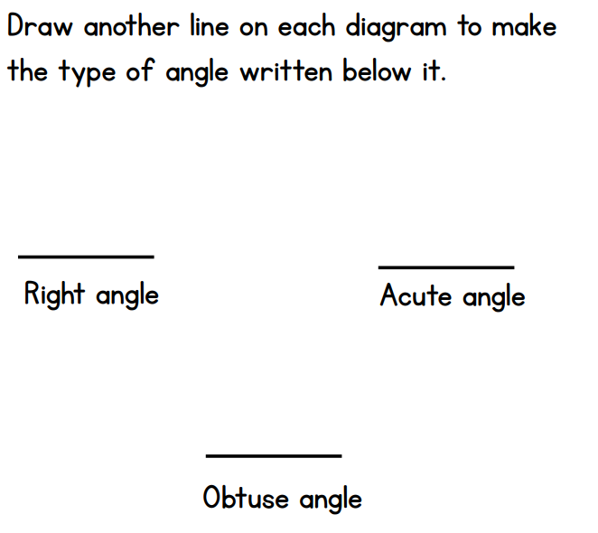 |  |  | English  Can you create a tourist’s guide for Hadrian’s wall or another famous Roman site? Remember, you need to try to convince people that Hadrian’s wall is the place to visit this summer! |  |  |  | English  Can you write a dairy entry in the character of a Roman Solider? You might want to research what life was like as a Roman Solider to help you complete this activity.
Art  First research some different Roman pottery and discuss what might the Romans have used them for, how they were made and how they were decorated. Then, design your own pottery and explain why you have used those colours and patterns. |  |  | RE  Our learning question in RE this is ‘What is a pilgrimage?’ Can you write about a special journey you may have been on before? |  | Art  Research why some Romans wore Laurel Wreaths and have a go at making your own! |  |  | History  Make a leaflet all about Roman soldiers. Research and find some facts about the things they had to wear and how it protected them. | Science  Follow the link below and watch the video and have a go at the quiz on the digestive system. Then have a go at making and labelling the digestive system using play dough! https://www.bbc.co.uk/bitesize/topics/z27kng8/articles/z9wk7p3  If you would like to go a step further to learn how our food passes through our digestive system, have a go at the experiment below.
Reading – Children should be encouraged to read every day. Please spend 5 or 10 minutes listening to your child read and discussing their books. We would love to know about what books you have been reading, so why not write a book review when you have finished! |  |  |  |  |  | Maths – All children from Year 1 to Year 6 have all been provided with a log in for Times Table Rockstars or Numbots. Children should be completing at least 3x5 minutes each week. If you have lost/can’t remember your login, please contact Miss Yarsley or Mr Edge on Class Dojo.



