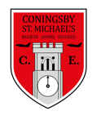 | Class:  4Y and 4E | Learning question for the term:  Are we just one country? |  |  |  |  | Science focus for the term:  Electricity |  |  | English Texts for this term:  Manfish by Jennifer Berne
At Coningsby St Michael’s, we believe all areas of the curriculum are important. This term we would like you to choose a minimum of 4 activities from the grid below, as your homework tasks. Other than reading and times table practise, no weekly homework will be set. We hope that this style of homework will encourage everyone to take part and give parents a chance to become more involved in working with their children on fun, creative and exciting activities. Children’s completed homework tasks will be recorded and monitored. Children who successfully engage in home learning tasks will be rewarded at school.
Please ask parents, family members or friends to join in and have fun. You can you use your homework task book for writing tasks, evidence logs, saving photos or collecting any other evidence of your learning. When each task is completed you need to bring it in or take photographs. The photographs do not have to be printed and can be sent to your class teacher using Class Dojo. When evidence is seen we will tick off your tasks and record your choices. We are hoping by giving everyone choices that a selection of activities will be completed by pupils with support from family members. Teachers will speak to parents if children are not engaging in home learning activities.
Maths  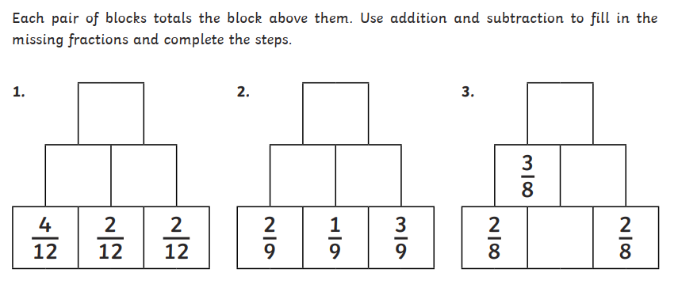 |  |  |  | Maths  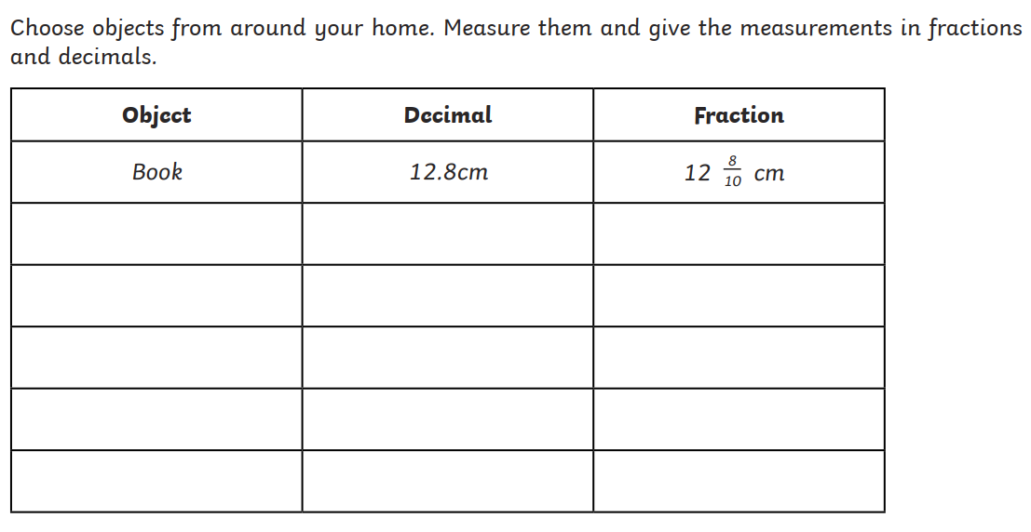 |  | PE  Our focus in PE this term is Athletics. There are many different types of throwing techniques used in athletics. The one-handed pull throw technique is used for the javelin.  This is the same technique used for an overarm throw in cricket.  See how far you can throw a ball using the one-handed pull throw (overarm throw). See how accurately you can throw by placing hoops or markers  to aim for. |  |  | PE  Practise your running technique whilst  running on the spot.  Get a friend or family member to check you are doing  the following things:  • Light, quick movements on  the feet, Keeping a relaxed body, Lifting the knees up to  a horizontal position, Keeping the arms bent and pumping, Keeping the head still and looking ahead. |  | English  Can you create a fact file or poster all about a sea creature? Think about their habitat, what they eat, their appearance or whether or not they are becoming endangered. Try to include some interesting facts too!
Art  This term in Art, we are looking at digital art. Photographs are used in lots of different ways in artwork. Sometimes the colours are changed or the picture is duplicated so that you have more than one version. Using a camera or mobile device, take a portrait or landscape picture and use your computer skills to edit it and then print it out. Alternatively you could send your finished version through Dojo. |  |  | RE  Our learning question in RE continues to be ‘What is a pilgrimage?’ Think of a special place that you want to visit. Make a plan for the pilgrimage – what will you need to take with you? How will you get there? |  | Art  Have a look for a piece of artwork that you have seen around that you like – it may be a picture you have hanging up at home or in school, it may be one that you have seen in a museum or in a book. Think carefully about the shapes in the picture and colours used, can you recreate it using a computer programme? |  |  | Geography  Make a list of all the countries you are linked with. It might be places you or your family have visited, or places you have friends or family. Maybe you have a pen pal somewhere? Do you have a favourite story that is set in another country? Maybe your favourite sports team has players from overseas? Where does your favourite food come from? |  |  | Science  Record all the different ways that you have used electricity today e.g. switched on the lights, played on a tablet etc. Now decide if this is an ‘essential’ use e.g. cooking food or a ‘non-essential’ use such as watching television. How many times did you use electricity that was essential?  How many times did you use electricity that was non-essential?
Reading – Children should be encouraged to read every day. Please spend 5 or 10 minutes listening to your child read and discussing their books. We would love to know about what books you have been reading, so why not write a book review when you have finished! |  |  |  |  |  |  | Maths – All children from Year 1 to Year 6 have all been provided with a log in for Times Table Rockstars or Numbots. Children should be completing at least 3x5 minutes each week. If you have lost/can’t remember your login, please contact Miss Yarsley or Mr Edge on Class Dojo.

