Year 4 Term 6 Curriculum
As Coningsby Authors we will be:

Exploring the text ‘Manfish’.

We will be writing:

1) An invention narrative
2) A biography of Jacques Cousteau
As Coningsby Scientists we will be:

Investigating circuits and their components.
Investigating the differences between mains and battery-powered circuits.
Recognising some common conductors and insulators, and associate metals with being good conductors.
Investigating the purposes of conducting and insulating materials.
Using knowledge of conductors and insulators to create switches to complete a circuit?

Welcome back to our new term.

Please remember this term… Reading books and reading records in school every day. Homework will be set termly and the children have home learning books. Our PE days are Wednesday and Friday

As Coningsby Mathematicians we will be:

Interpreting charts
Comparing data
Creating line graphs
Finding right angles in shapes
Identifying, comparing and ordering angles
Learning about triangles and quadrilaterals
Identifying lines of symmetry and completing symmetrical figures
Describing position and movement on a grid

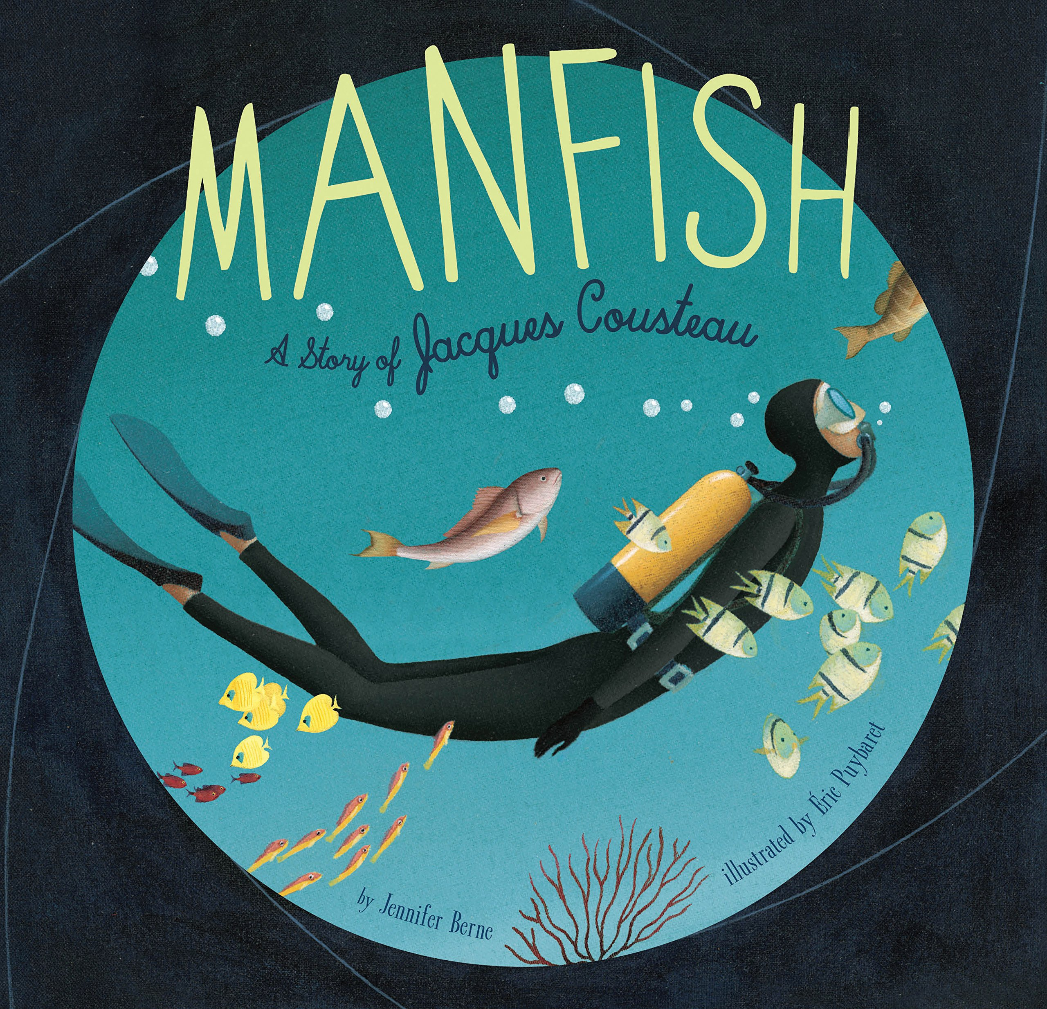

As Coningsby Artists & Designers we will be:
Using Pointillism to create works of art.
Reproducing artwork in the style of Mondrian.
Making and editing shapes to create a piece of art.
Changing the shade of a colour for effect.
Experimenting with pop art styles used by the artist Andy Warhol.
Using a range of skills to create a masterpiece.
As Coningsby Geographers we will be:

Finding the location of the Northern and Southern Hemisphere, the Equator, the Tropic of Cancer and Capricorn.

Finding out the difference between the United Kingdom and the British Isles.

Locating and writing about the main islands that surround the United Kingdom and their main features.
As Coningsby believers we will be:

Looking at what pilgrimage is and how followers of different faiths undertake a pilgrimage

Consider our school value of ‘Truthfulness.’

