Year 4 Term 2 Newsletter
Dear parents of year 4:
We hope you all had a restful half term. We are very excited to be back to a new term. If you have any questions, please do not hesitate to contact us on Class Dojo.
Please remember this term… reading books and planners in school every day.
Foxes have outdoor PE on a Monday and indoor PE on a Tuesday.
Otters have Forest School on a Tuesday and PE on a Wednesday.

As Coningsby Scientists we will:
This term in science, we are continuing our learning on States of Matter. We will be exploring lots of different experiments, including the ‘Dancing Raisins experiment’ to investigate how solids and gasses behave. We will discuss why some solids act like liquids as well as understanding and investigating the processes of evaporation and condensation.

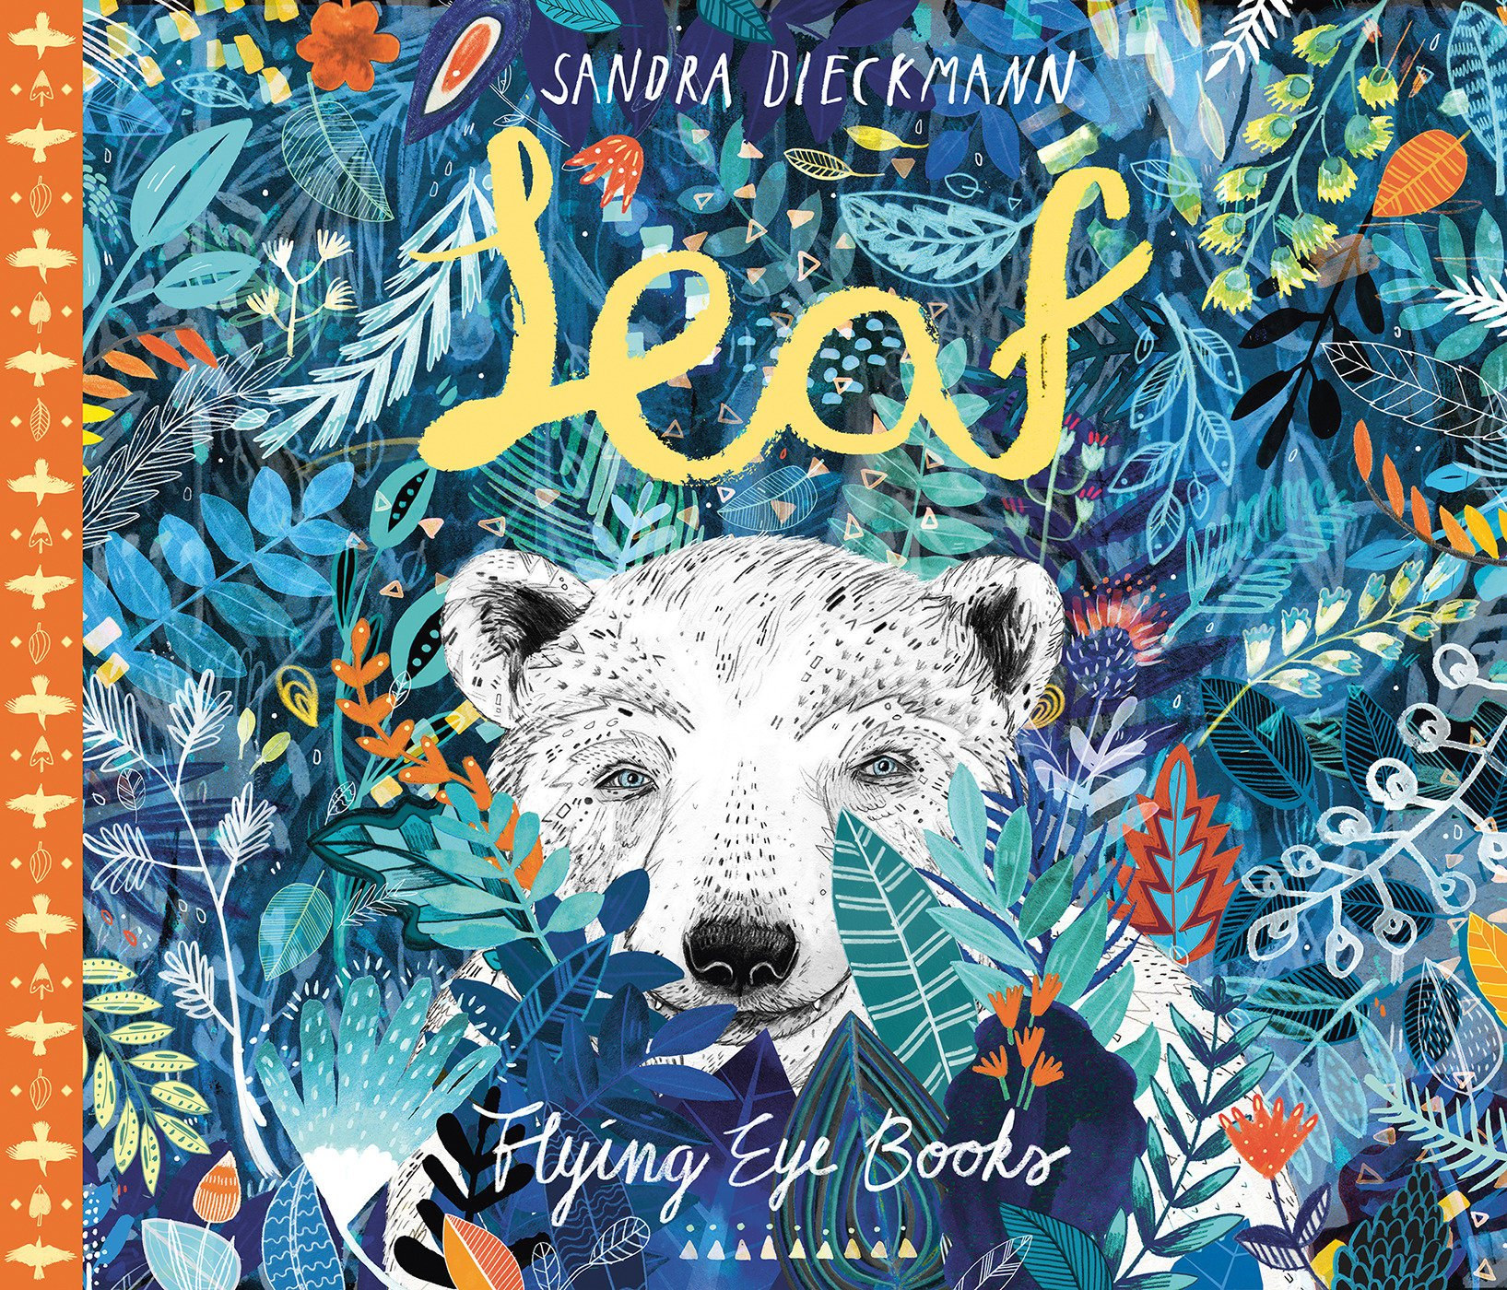
As Coningsby Geographers we will:

Be locating the northern hemisphere, the southern hemisphere and the equator as well as learning a little bit about the countries in these hemispheres and those that lie on the equator. We will then learn about the polar regions and who lives there as well as discover who the Inuit’s are and how the climate affects their way of life.
As Coningsby Mathematicians we will:
Our main focus at the beginning of the term will be area before moving on to practice our 3-, 6- and 9-times tables and discovering the link between these. We will then move onto our 7-, 11- and 12-times tables.

As Coningsby Artists & Designers we will:

Be learning all about different still life paintings and exploring the work of different artists. We will look at how to create reflections in our artwork. Towards the end of term, we will move onto Design and Technology.
As Coningsby Authors we will:

Be exploring our book, ‘Leaf’ by Sandra Dieckmann. It is a beautifully illustrated book, and we will be using the illustrations to predict and make inferences about the story before writing an outsider narrative. Towards the end of term, we will be researching and writing a non-fiction piece of writing all about polar bears.
As Coningsby believers we will:
Be learning all about Hinduism. We will look at where Hindus worship, we will learn more about Diwali and we will ask ‘what is Raksha Bandhan’?

