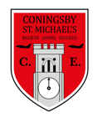 | Class:  Otters and Foxes | Learning question for the term:  How can the weather cause so much trouble? |  | Science focus for the term:  States of matter | English text for the term;  Leaf – Sandra Dieckman |  | RE focus for the term:  How do Hindus worship?
At Coningsby St Michael’s, we believe all areas of the curriculum are important. This term we would like you to choose a minimum of 4 activities from the grid below, as your homework tasks. Other than reading and times table practise, no weekly homework will be set. We hope that this style of homework will encourage everyone to take part and give parents a chance to become more involved in working with their children on fun, creative and exciting activities. Children’s completed homework tasks will be recorded and monitored. Children who successfully engage in home learning tasks will be rewarded at school.
Please ask parents, family members or friends to join in and have fun. You can you use your homework task book for writing tasks, evidence logs, saving photos or collecting any other evidence of your learning. When each task is completed you need to bring it in or take photographs. The photographs do not have to be printed and can be sent to your class teacher using Class DoJo. When evidence is seen we will tick off your tasks and record your choices. We are hoping by giving everyone choices that a selection of activities will be completed by pupils with support from family members. Teachers will speak to parents if children are not engaging in home learning activities.
Maths  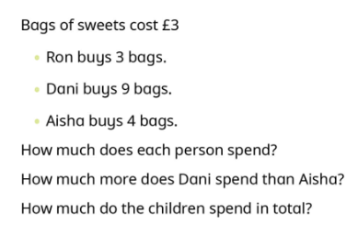 |  |  | English  This term in English we are going to write a factfile about a polar bear. Can you write a factfile about another animal from our book ‘Leaf’? You could choose from a fox, crow, badger, owl, beaver, butterfly, wolf or hare. | Science  Choose a science experiment from https://lifestyle.howstuffworks.com/crafts/science-projects/science-projects-for-kids-states-of-matter.htm#pt4 to investigate states of matter. |  | Art  Sill life is a term used in Art to describe objects that are in our daily lives. Can you collect some still life objects from around your house and create some observational drawings?
RE  https://www.bbc.co.uk/bitesize/articles/z43v382 Using this link, watch some videos to tell you a little bit more about Hinduism. Can you then have a go at drawing the aum symbol and research what it represents. |  |  | Geography  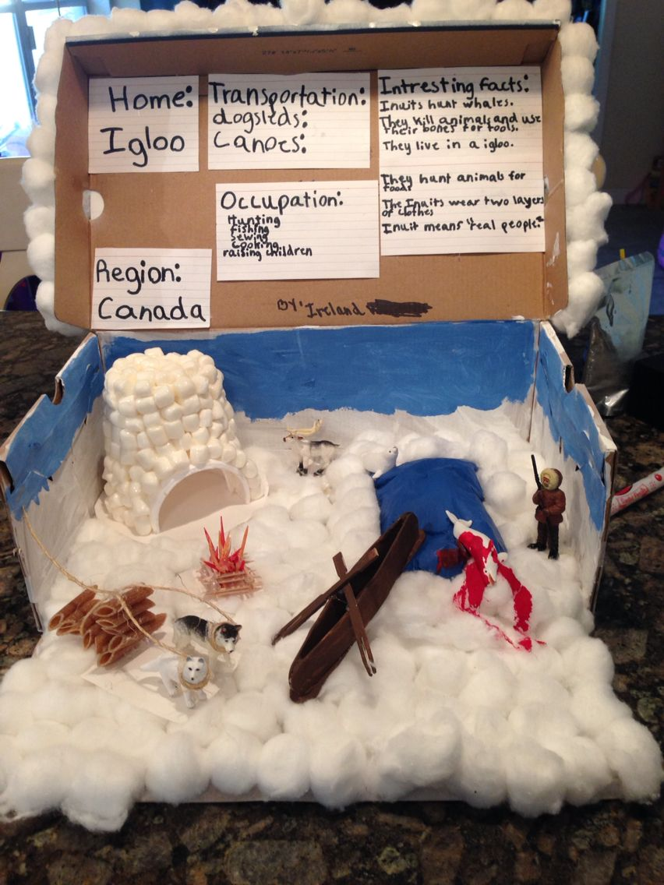  Using a shoebox, can you create an ‘Inuit Diorama’ like the one in the picture. Can you include some facts about the Inuit’s? | SPaG  Using the ‘in’, ‘im’, ‘il’ and ‘ir’ prefixes.  Can you add the correct prefix to each word, changing the meaning to ‘not’ or ‘opposite of’?  For example, resistible >>>> irresistible  Expensive  Offensive  Literate  Mature  Repairable  Proper  Distinct  Logical |  | Art  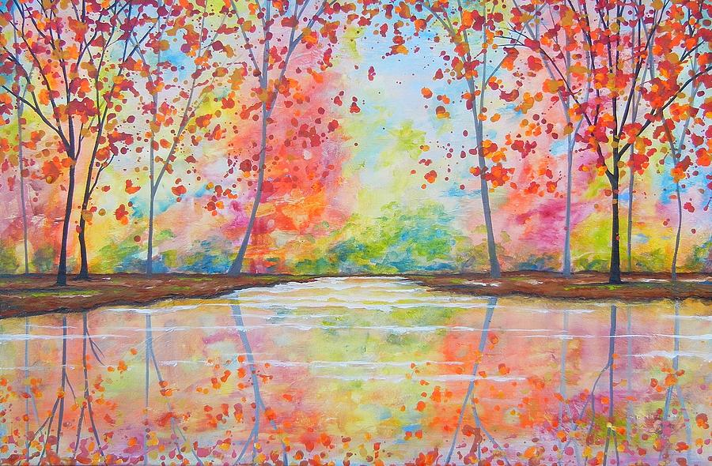  This term in Art, we will be looking at using reflections in our art work. Can you create an autumnal picture using reflection in your work like the one below?
Maths  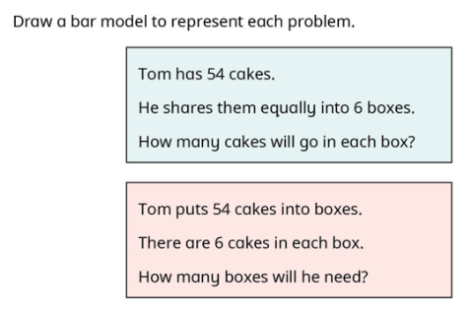 |  |  |  | English  Pick a country of your choice, you could stick with our country or you could pick a faraway country that you might have been to or would like to visit in the future. Can you research this country and create an advert to persuade people to visit? You might like to do this on the computer using PowerPoint.
Reading – Children should be encouraged to read every day. Please spend 5 or 10 minutes listening to your child read and discussing their books. |  |  |  | Maths – All children from Year 1 to Year 6 have all been provided with a log in for Times Table Rockstars or Numbots. Children should be completing at least 3x5 minutes each week.

