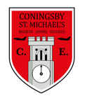 | Class:  Year 4  Otters and Foxes | Learning question for the term:  Can you walk like an Egyptian? |  | Science focus for the term:  Sound | English text for the term:  Arthur and the Golden Rope |  | RE focus for the term:  Islam – How do Muslim’s worship?
At Coningsby St Michael’s, we believe all areas of the curriculum are important. This term we would like you to choose a minimum of 4 activities from the grid below, as your homework tasks. Other than reading and times table practise, no weekly homework will be set. We hope that this style of homework will encourage everyone to take part and give parents a chance to become more involved in working with their children on fun, creative and exciting activities. Children’s completed homework tasks will be recorded and monitored. Children who successfully engage in home learning tasks will be rewarded at school.
Please ask parents, family members or friends to join in and have fun. You can you use your homework task book for writing tasks, evidence logs, saving photos or collecting any other evidence of your learning. When each task is completed you need to bring it in or take photographs. The photographs do not have to be printed and can be sent to your class teacher using Class DoJo. When evidence is seen we will tick off your tasks and record your choices. We are hoping by giving everyone choices that a selection of activities will be completed by pupils with support from family members. Teachers will speak to parents if children are not engaging in home learning activities.
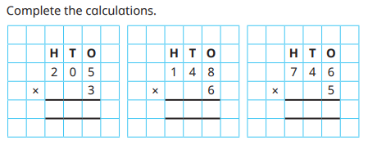  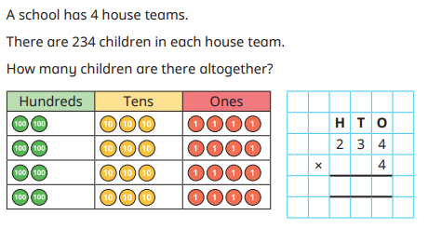  Maths  Can you make up your own questions like this? |  |  | English and SPaG  See the activities below, these relate to our text for this term – Arthur and the Golden Rope. | Science - Make shakers with different materials inside to make different types of sounds. If you can, ask a family member to try to guess what is in each shaker. Can you make shakers with high and low sounds, loud and soft sounds, and short and long sounds?  You could also record yourself playing each different sound using the shakers you have made and send these to us on class dojo. |  | History – Write your name and the names of 3 friends or family members in hieroglyphics.
Art - Make a Salt Dough Scarab
Beetle Craft Activity – See the details below.

 |  |  | Art - Ancient Egyptians liked gold jewellery, can you design and make your own gold bands and collars? Old plastic water bottles are good for cuffs, cut a ring, cover in foil or paint then add details with beads for jewels or felt tip for patterns. Use could also use card for a collar. | Maths – Draw a map of a pharaohs tomb. Write a set of instructions on how to safely get through avoiding any traps! Think about using directional language. |  | English – Choose an ancient Egyptian god or goddess and create a fact file, book or poster all about them.
Science - Take a walk around indoors or outside to identify and describe the sounds you can hear. What is making each sound? Can you hear high and low sounds? Can you hear loud and quiet sounds?  How did the sound reach your ears? Choose one of the sounds your heard and draw or write about how that sound travelled from its source to your ear. |  |  |  | RE - Design your own Muslim prayer mat. Remember to include key Muslim  symbols or buildings. Also include drawings of things that are important to  you. Remember that Muslims use a lot of geometrical patterns, so you can  include patterns on your mat but images of animals or people should not be used.
Reading – Children should be encouraged to read every day. Please spend 5 or 10 minutes listening to your child read and discussing their books. |  |  |  | Maths – All children from Year 1 to Year 6 have all been provided with a log in for Times Table Rockstars or Numbots. Children should be completing at least 3x5 minutes each week.



