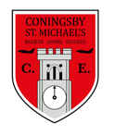 | Class:  Year 4  Otters and Foxes | Learning question for the term:  Are we welcome in the rainforest? |  | Science focus for the term:  Animals and their habitats | English text for the term:  The Lost Happy Endings |  | RE focus for the term:  The Christian creation story.
At Coningsby St Michael’s, we believe all areas of the curriculum are important. This term we would like you to choose a minimum of 4 activities from the grid below, as your homework tasks. Other than reading and times table practise, no weekly homework will be set. We hope that this style of homework will encourage everyone to take part and give parents a chance to become more involved in working with their children on fun, creative and exciting activities. Children’s completed homework tasks will be recorded and monitored. Children who successfully engage in home learning tasks will be rewarded at school.
Please ask parents, family members or friends to join in and have fun. You can you use your homework task book for writing tasks, evidence logs, saving photos or collecting any other evidence of your learning. When each task is completed you need to bring it in or take photographs. The photographs do not have to be printed and can be sent to your class teacher using Class DoJo. When evidence is seen we will tick off your tasks and record your choices. We are hoping by giving everyone choices that a selection of activities will be completed by pupils with support from family members. Teachers will speak to parents if children are not engaging in home learning activities.
Maths  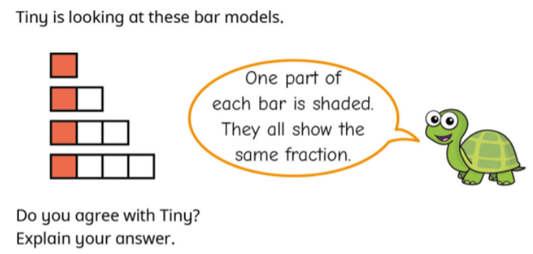  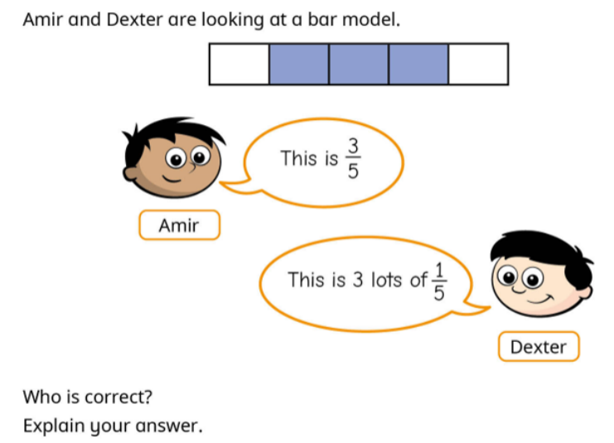 |  |  | English and SPaG -  Write a character description of either Jub or the Witch from ‘The Lost Happy Endings.’ Don’t forget to include details about their physical appearance AND their personality. | Science –  Can you design your own creature? Where does your creature live? Is it hot or cold? Dry or wet? Is it a predator or prey? Does it have clever ways of hunting or keeping safe? How does your creature move? Wings? Legs? Does it have skin, feathers or scales? Why? What does it eat? |  | Geography –  Design your own ‘Save the Rainforest’ poster. Make sure you include
Maths -
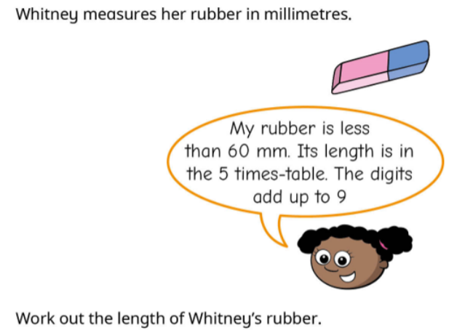
 |  |  | PSHE -  How do you keep your body and mind healthy? Take a moment to write a lost of the ways you stay healthy. Do you eat healthy meals? Exercise? Write in a journal/ diary? Do you talk to someone when you have had a tough day? | RE - Create a poster filled with everything you think is wonderful about our world. What can humans do to protect and look after these wonderful things? |  | English –  Have a go at writing a traditional story or tale but with an alternative ending. You could use an ending from a different story that you know or you could make up your own different ending.
Science - Go on a nature walk with your family and see how many different animals and habitats you can spot. Can you group the animals you have seen into types of species? |  |  |  | 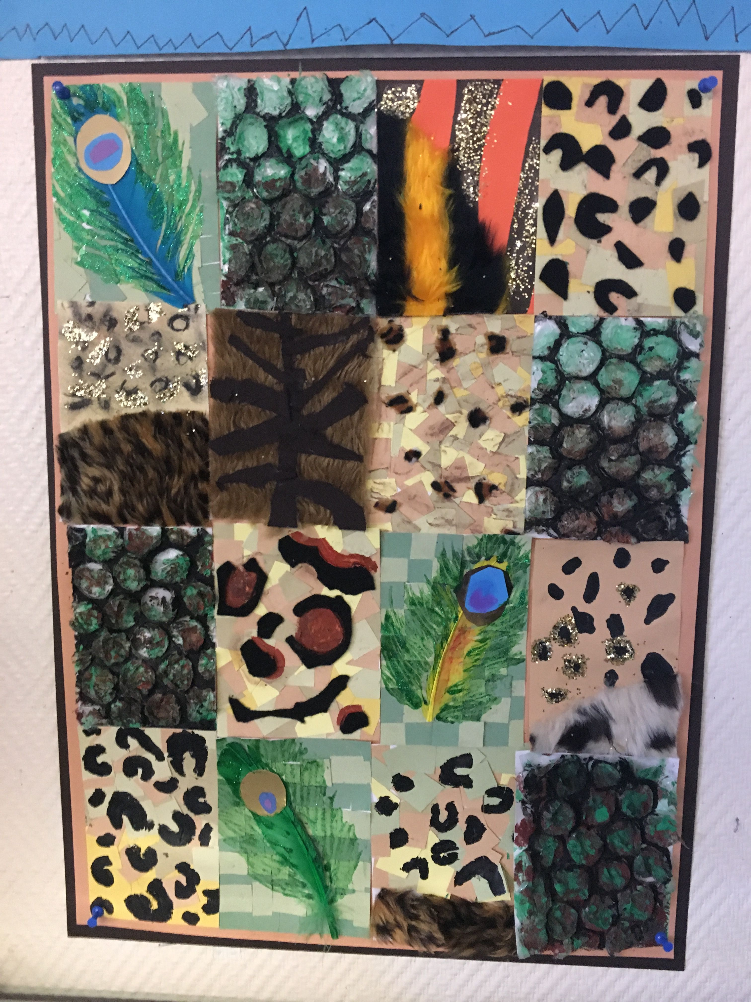  Art – Use different mediums such as collage materials, paints, pencils, printing to create a collage of different animal prints.
Reading – Children should be encouraged to read every day. Please spend 5 or 10 minutes listening to your child read and discussing their books. |  |  |  | Maths – All children from Year 1 to Year 6 have all been provided with a log in for Times Table Rockstars or Numbots. Children should be completing at least 3x5 minutes each week.

