Year 4 Term 5 Newsletter
Dear parents of year 4:
We hope you all had a wonderful Easter. We are very excited to start our new topics this term. If you have any questions, please do not hesitate to contact us on Class Dojo.
Please remember this term… reading books and planners in school every day.
Foxes have Forest School on a Wednesday morning and outdoor PE on a Monday afternoon.
Otters have outdoor PE on a Wednesday and Friday.
Thank you!
As Coningsby Scientists we will:
Be exploring the human body! Our science topic starts off with us exploring what different animals eat and recapping what herbivores, carnivores and omnivores are. We will then move on to the different types of teeth that humans have and their part in the digestive system. The digestive system is the last part of our science topic and we will be carrying out some fun investigations.

As Coningsby Mathematicians we will:
Start the term by looking decimals and how we would write ¼ ½ and ¾ as decimals. We will then move on to money and problem solving. Towards the end of term, we will be looking at time and converting between analogue and digital clocks.

As Coningsby Historians we will:
Be going to Ancient Greece! We will be looking at when Ancient Greece started and what life was like for people who lived there during this time. We will look at how people traded goods and how life changed after the Persians invaded Greece. We will also be studying timelines to help us understand what else was going on in the world during the Ancient Greek era.
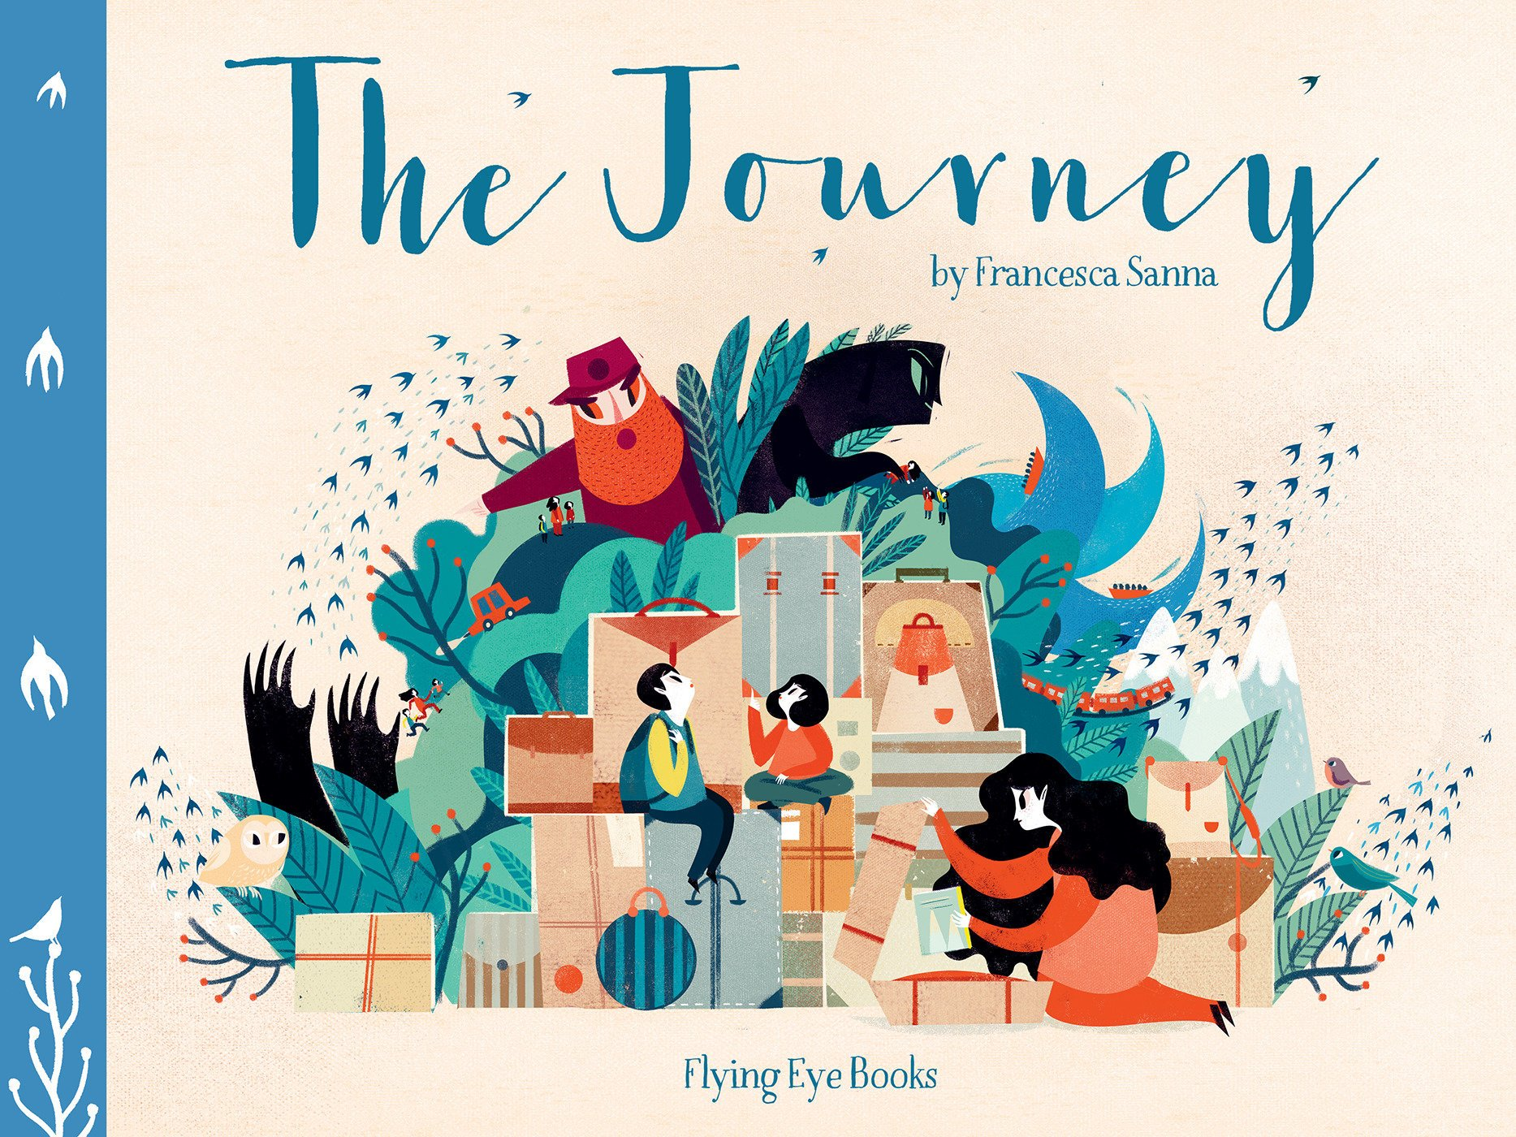
As Coningsby Authors we will:
Be exploring our book, The Journey by Francesca Sanna. It tells the story of a refugee family fleeing a war-torn country through beautiful words and illustrations. We will be writing a refugee narrative of our own, building on our ever-growing year four knowledge of writing. We will also be writing a diary entry towards to the end of term. We will continue to use our grammar and punctuation expectations to really embed this in our writing.
As Coningsby believers we will:

Learning about pilgrimage across different faiths. We will be looking at why people from different faiths go on religious pilgrimages, where they go and what they do when they have arrived. We will look at similarities and differences between pilgrimages, particularly why Jerusalem is such an important place in many faiths.
As Coningsby Artists & Designers we will:

Be focussing on drawing. We will explore using different techniques to create different effects. We will create our own drawings using techniques to create texture and depth. We will be looking at the life and works of Vincent Van Gogh and Lawrence Steven Lowry.

