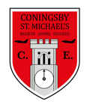 | Class:  Year 4  Otters and Foxes | Learning question for the term: |  | Science focus for the term:  Animals including humans | English text for the term:  The Journey by Francesca Sanna |  | RE focus for the term:  Pilgrimage
At Coningsby St Michael’s, we believe all areas of the curriculum are important. This term we would like you to choose a minimum of 4 activities from the grid below, as your homework tasks. Other than reading and times table practise, no weekly homework will be set. We hope that this style of homework will encourage everyone to take part and give parents a chance to become more involved in working with their children on fun, creative and exciting activities. Children’s completed homework tasks will be recorded and monitored. Children who successfully engage in home learning tasks will be rewarded at school.
Please ask parents, family members or friends to join in and have fun. You can you use your homework task book for writing tasks, evidence logs, saving photos or collecting any other evidence of your learning. When each task is completed you need to bring it in or take photographs. The photographs do not have to be printed and can be sent to your class teacher using Class DoJo. When evidence is seen we will tick off your tasks and record your choices. We are hoping by giving everyone choices that a selection of activities will be completed by pupils with support from family members. Teachers will speak to parents if children are not engaging in home learning activities.
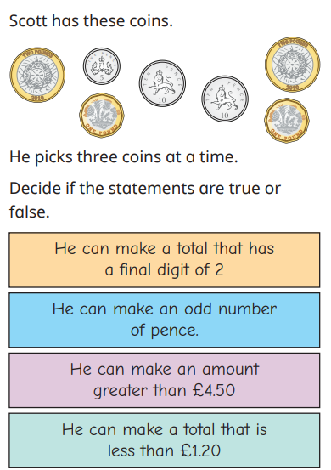  Maths |  |  | SPaG – Sort these words into 2 groups, those ending in the suffix ‘ture’ and those ending in the suffix ‘sure’. Can you pick 5 and find their meaning? Can you then use them in a sentence? Once you have done that, make sure you can spell all of these words correctly.  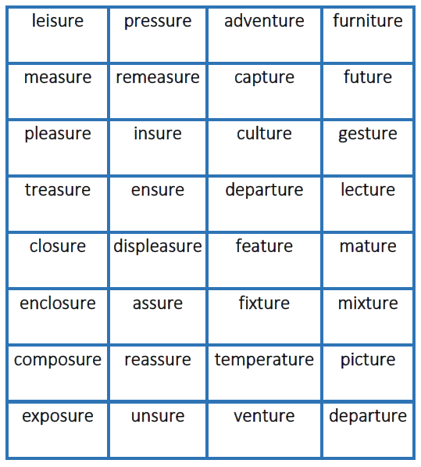 | Science – Can you research and have a go at drawing our digestive system? Can you then label it using the key words below?  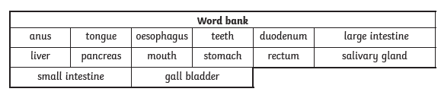 |  | History –  Design on ancient Greek pottery telling us lots about what life was like in ancient Greece. Some vases or pots have images showing us daily life in ancient Greece, some show battle scenes and some show scenes from myths (sometimes including images of the Greek gods). Design your own Greek pot and write a description about your design describing what you have included.
Maths -
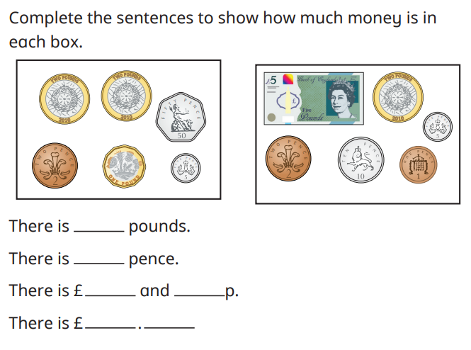
 |  |  | PSHE – This term we are focusing on relationships. Can you write a recipe for a good friendship? What should it include and how can you make sure you maintain that friendship? | RE – Create a poster about a special journey that you and your family went on. Who went on that journey? Where did you go? How long did it take to get there? How did you get there? What did you do and see when you got to your location? |  | English – This term in English we are writing a diary entry,
History – Temples were the most common type of public building in ancient Greek times. The main purpose of a temple in ancient Greece was to honour a god or goddess and to to display a statue of them. Follow the instructions on the separate sheet to make your own ancient Greek temple. |  |  |  | Art – This term in Art, we are focussing on the different techniques used by the artists Van Gogh and Lowry. Can you research some other artists and try and replicate one of their pieces of work? You might want to look at Willem Kalf, a Dutch painter or Paul Cezanne, a French artist.
Reading – Children should be encouraged to read every day. Please spend 5 or 10 minutes listening to your child read and discussing their books. |  |  |  | Maths – All children from Year 1 to Year 6 have all been provided with a log in for Times Table Rockstars or Numbots. Children should be completing at least 3x5 minutes each week.

