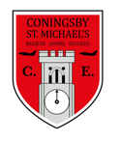 | Class:  Year 4  Otters and Foxes | Learning question for the term:  Are we just one country? |  | Science focus for the term:  Electricity | English text for the term:  Manfish: A story of Jacques Cousteau by Jennifer Berne. |  | RE focus for the term:  Pilgrimage
At Coningsby St Michael’s, we believe all areas of the curriculum are important. This term we would like you to choose a minimum of 4 activities from the grid below, as your homework tasks. Other than reading and times table practise, no weekly homework will be set. We hope that this style of homework will encourage everyone to take part and give parents a chance to become more involved in working with their children on fun, creative and exciting activities. Children’s completed homework tasks will be recorded and monitored. Children who successfully engage in home learning tasks will be rewarded at school.
Please ask parents, family members or friends to join in and have fun. You can you use your homework task book for writing tasks, evidence logs, saving photos or collecting any other evidence of your learning. When each task is completed you need to bring it in or take photographs. The photographs do not have to be printed and can be sent to your class teacher using Class DoJo. When evidence is seen we will tick off your tasks and record your choices. We are hoping by giving everyone choices that a selection of activities will be completed by pupils with support from family members. Teachers will speak to parents if children are not engaging in home learning activities.
Maths -  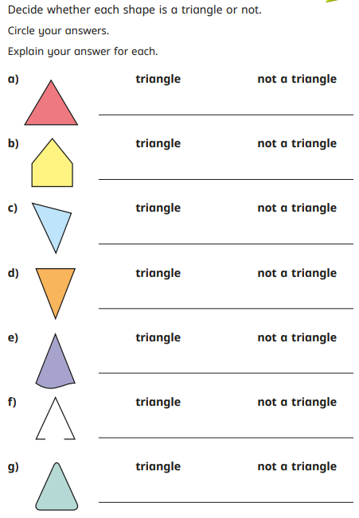 |  |  | SPaG –  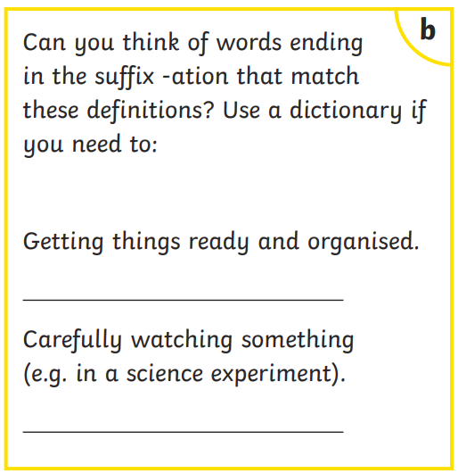 | Geography –  Choose a town or city in the UK and research some facts about it. Write a fact file about it. Can you include some pictures of landmarks that belong to that city? |  | RE –  Choose an important religious pilgrimage from any religion we have learned about. Write about the history of the journey and why it started. Draw a map to show how people get there.
Maths -
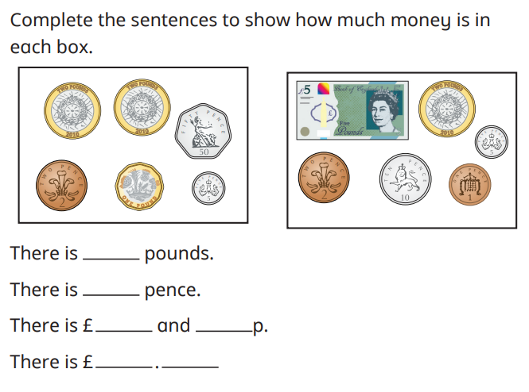
 |  |  | PSHE –  Write about some of the changes that have happened in year 4. What have you done that you are proud of?  Can you think of something you would like to achieve in year 5? | Art –  This term we are creating digital art. Use the app Assembly (if possible) to create your very own logo, representing parts of your personality. (ie, your favourite colours, food, hobbies). If you do not have access to a digital art program, create a logo using any art materials you can find. |  | English –  This term in English, we will be writing a biography of Jacques Cousteau. Think of someone who you admire or inspires you, do some research and write a biography about them.
Science –  Have a look at the following circuits and decide which bulbs will light up and which ones will not. Explain your answers.  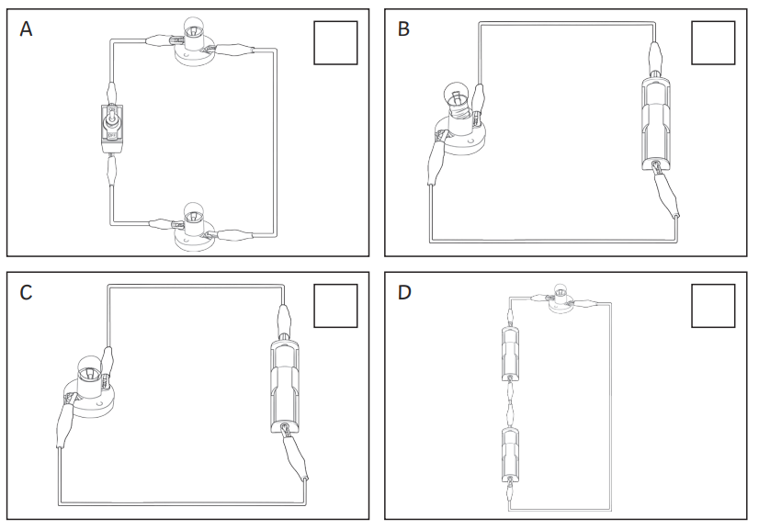 |  |  |  | Geography –  Create a shoebox diorama of your very own village, town or city. Can you label all the features of your town or city? Is it rural or urban? Is it near to the coast? Are there rivers running nearby?  We can’t wait to see your fantastic ideas!
Reading – Children should be encouraged to read every day. Please spend 5 or 10 minutes listening to your child read and discussing their books. |  |  |  | Maths – All children from Year 1 to Year 6 have all been provided with a log in for Times Table Rockstars or Numbots. Children should be completing at least 3x5 minutes each week.

