Year 4 Term 4 Newsletter
Dear parents of year 4:
We hope you all had a wonderful half term. We are very excited to start our new topics this term. If you have any questions, please do not hesitate to contact us on Class Dojo.
Please remember this term… reading books and planners in school every day.
Otters have Forest School on a Wednesday morning and indoor PE on a Friday afternoon.
Foxes have indoor PE on a Wednesday and outdoor PE on a Friday.
Thank you!
As Coningsby Scientists we will:
Be exploring a variety of habitats and exploring why organisms live in different habitats. We will group organisms according to their characteristics, use a classification key to identify animals as well as use a key to identify invertebrates. We will finish by discussing the environmental dangers to endangered species.

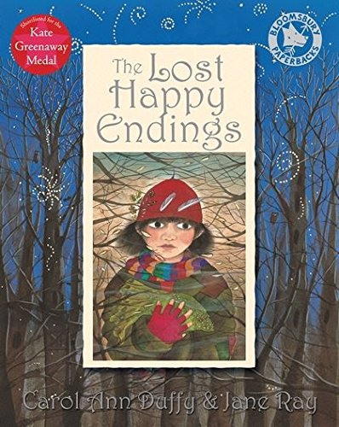
As Coningsby Mathematicians we will:
Start the term by looking at fractions by understanding a whole, a mixed number fraction and improper fractions. We will look at equivalent fractions on a number line and fraction families. We will then move onto adding and subtracting fractions.

As Coningsby Authors we will:

Be exploring our book, The Lost Happy Endings by Carol Ann Duffy. We will focus on writing a twisted narrative ending of a traditional tale as well as a persuasive letter.
We will build on previous writing units and focus on using noun phrases and fronted adverbials in our writing. There will be focus lessons on the year four grammar, spelling and punctuation expectations to really embed this in our writing.

As Coningsby Geographers we will:
Be exploring the rainforest! We will identify areas of the world containing rainforests as well as describing and understanding the features of the layers of a rainforest. We will investigate the climate of the rainforest and describe the animals that live there. We will find out about people and settlements of the rainforests and then explore why the rainforest is under threat and the measures taken to protect it.

As Coningsby believers we will:

Learning about Christians belief of the creation story. We will discuss what makes our world wonderful, and how we should treat the things that god created. We will also look at how the bible guides Christians through their life by helping them understand it and how to live it.
As Coningsby Artists & Designers we will:

Be focussing on printing. We will explore patters and artists who use patterns in their work. We will create our own patterns using rotation, symmetry and reflection. We will then use stencils to create patterns. We will finish the term by looking at the work of Henri Rousseau.

